# **Creating an ALARM for specific metrics:**

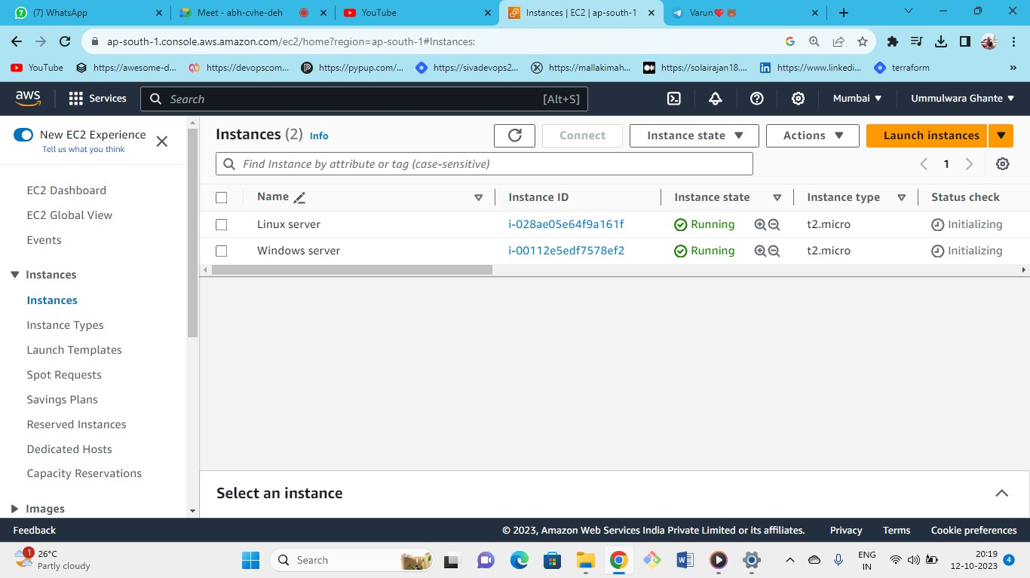



* Server(Linux)--->instance type(t2.micr0)--->keypair(create new or keep old one)--->security group (new or existing)-->storage(gp2)--->launch
* Server(windows)--->instance type(t2.micr0)--->keypair(create new or keep old one)--->security group (new or existing)-->storage(gp3)--->launch.

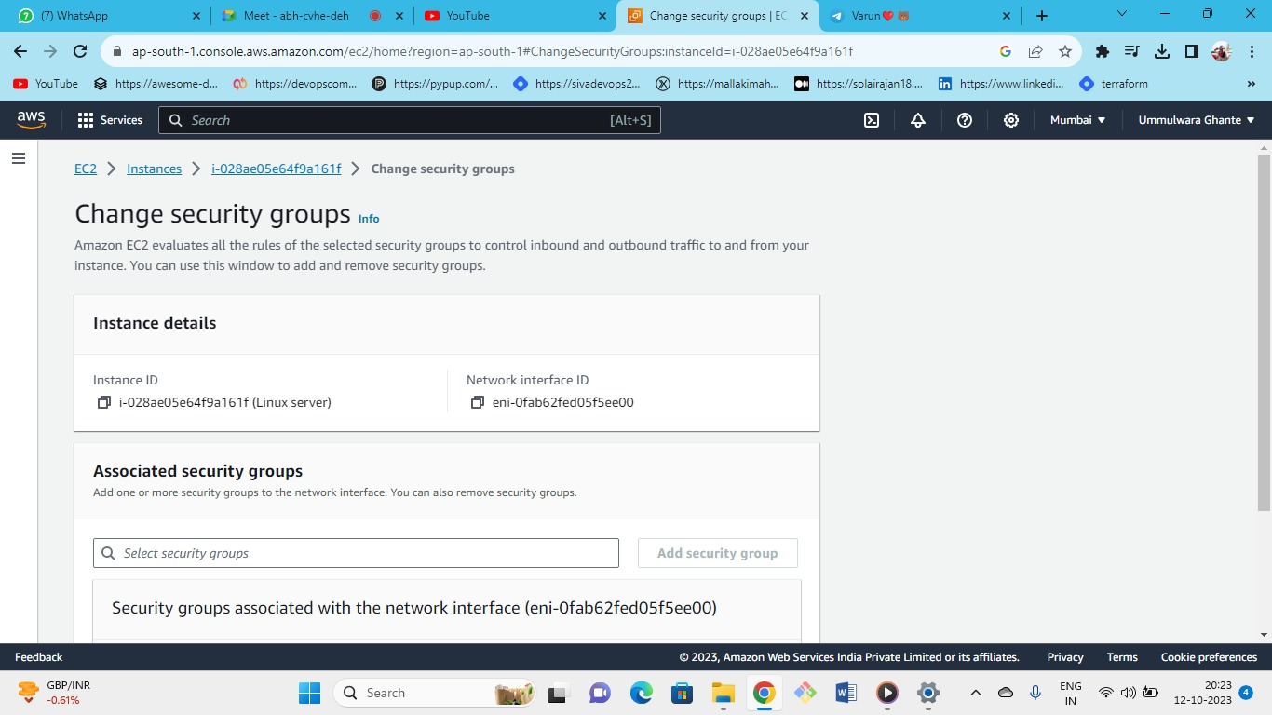



* you can add or change the security groups from here (add or remove).

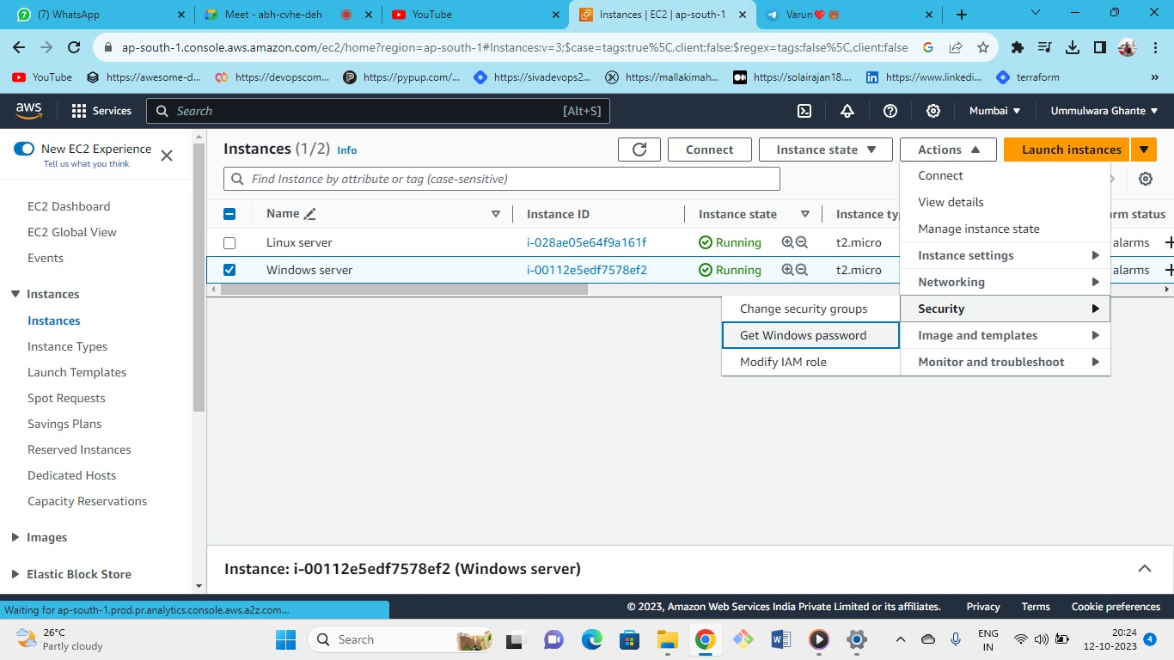



Security: Modify 3 things (security group ,windows password, IAM role)

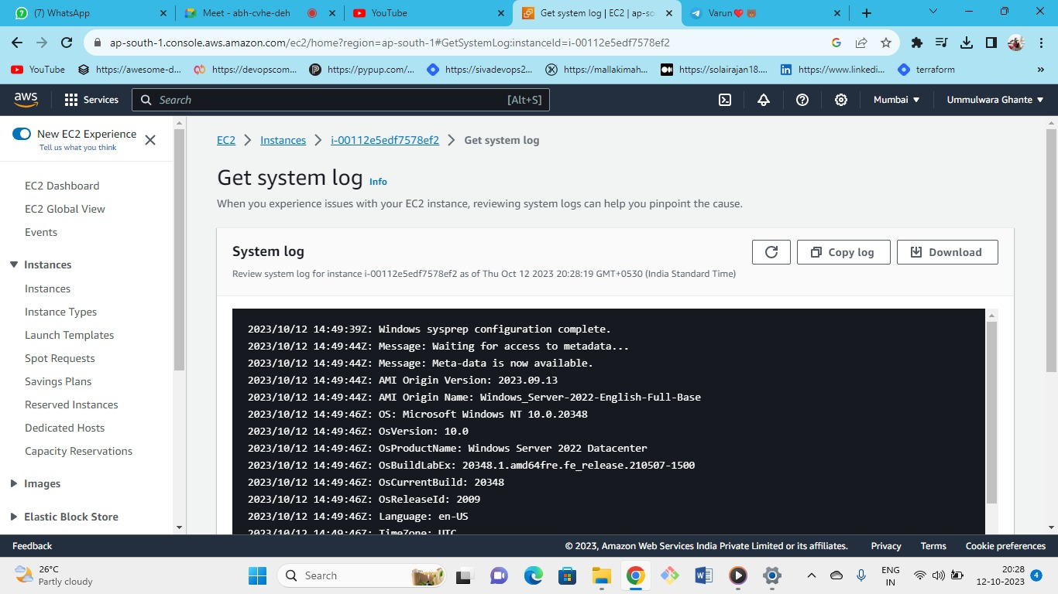



You can also get some system logs from here if you want detailed logs go to cloud watch logs.

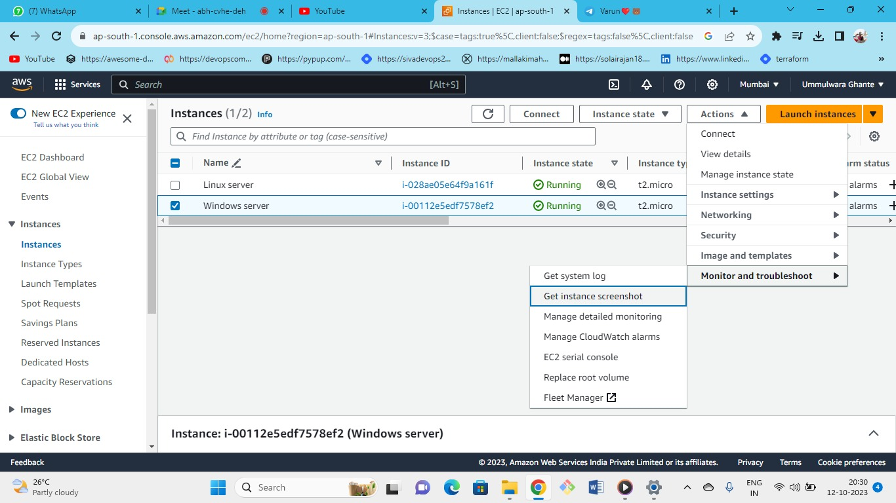



* If this window instance is not available in your local data center and present in AWS data center as you have no access to this server then we can have a screenshot of that server by this we can see if server is working properly or not.
* Screenshot for Windows Server

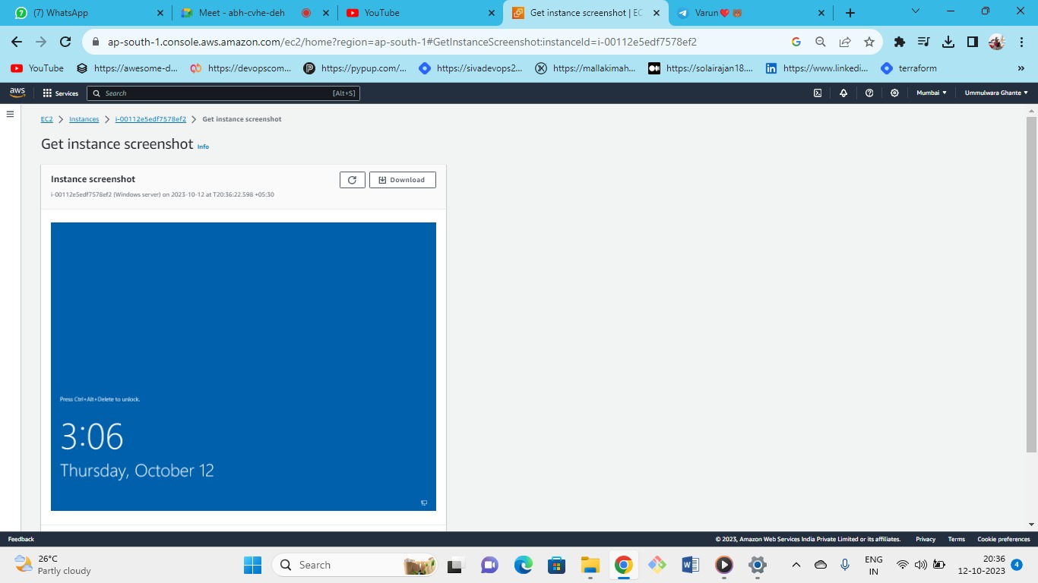



* This is windows instance screenshot If this appears then everything is working fine
* For Linux server this is the instance screenshot

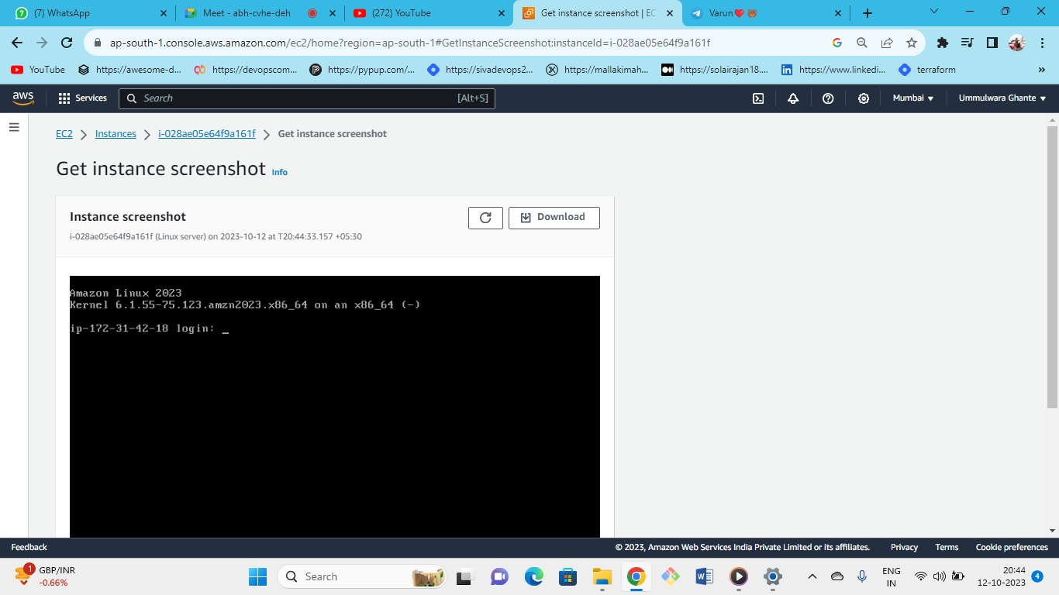



Following window appears for Linux instance

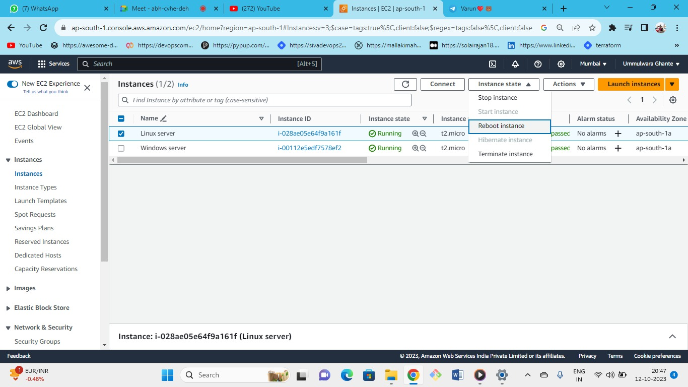



Now lets reboot the linux instance so see what appears at the instance screenshot

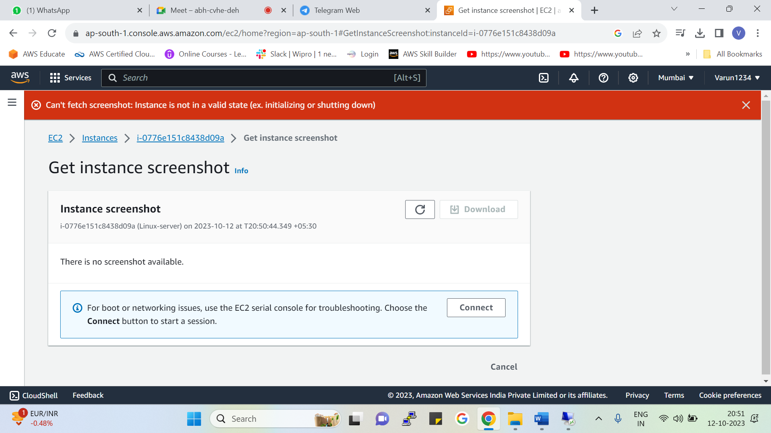



* Now we have rebooted the linux instance so we will get the following error in instance screenshot because its rebooting.
* If there is something wrong then it will showcase us the error or logs.
* But after successfully reboot we will get normal instance screen shot.





Now try to connect to Linux instance

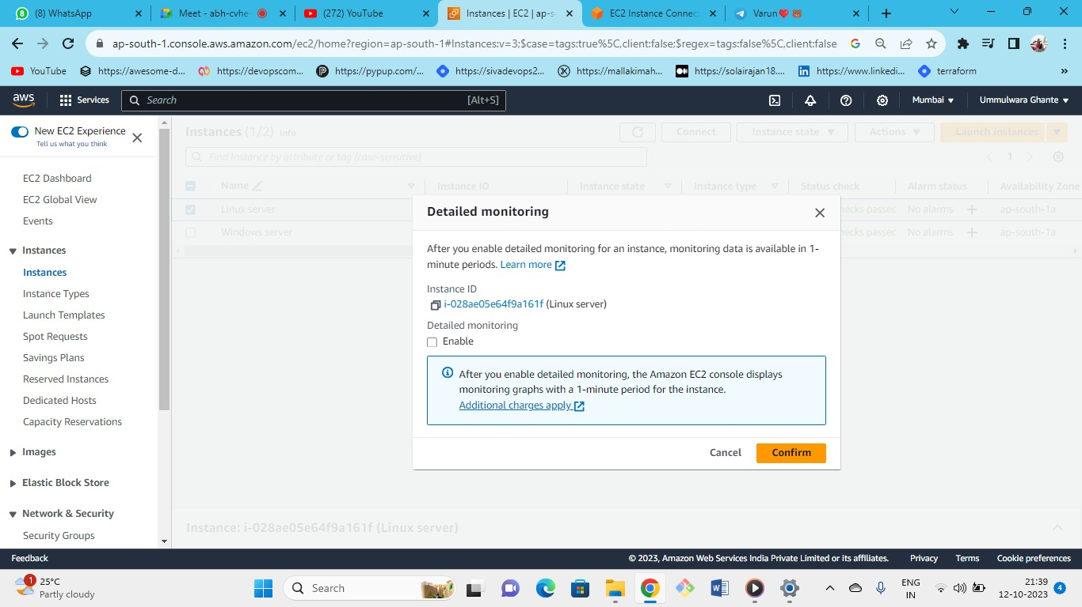



* we can manage the detail monitoring from here.
* as detail monitoring is not free but basic monitoring is free of cost.
* Status Check:
* Because of the hardware the system status check will fail always.
* And instance status check will fail because of the operating system status.

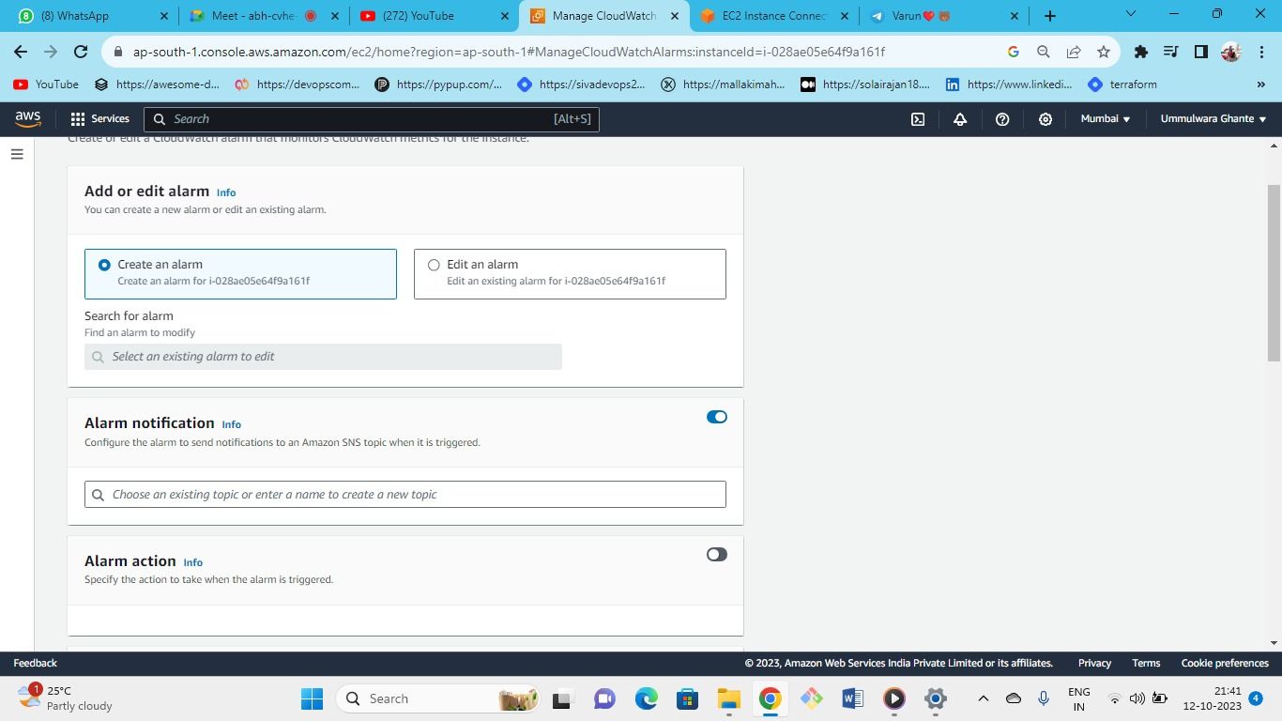



* CPU has reached above 90% then we can set an alarm for this, metric will give the alert on alarm for monitoring.
* Note: from metrics, we will get to know the behavior of the system.
* In case of CPU utilization is high, in case memory is high, in case of status check failure, we will get the notifications through the alarms.
* Or you can also set automated actions such as rebooting an EC2 or any other actions

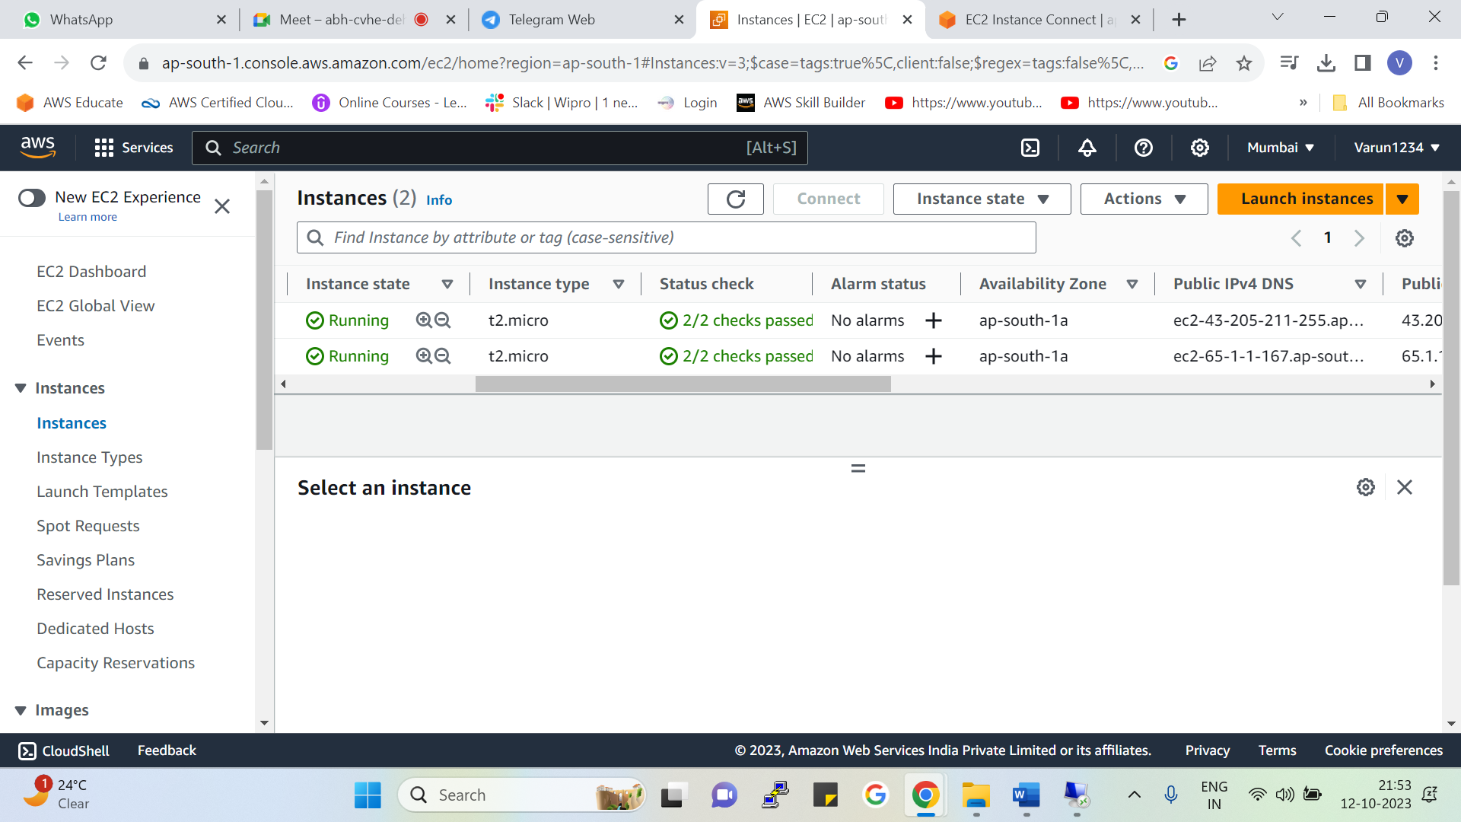



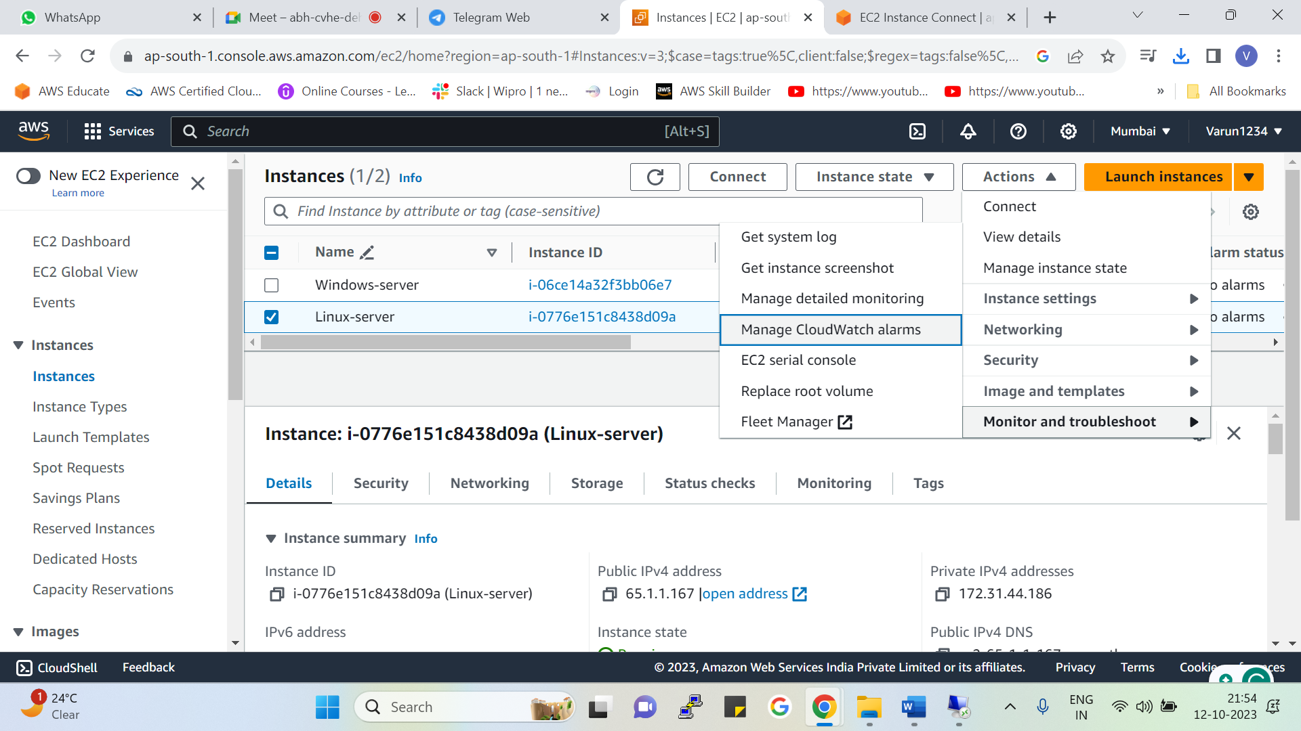



From the following 2 ways we can add the cloud watch alarms

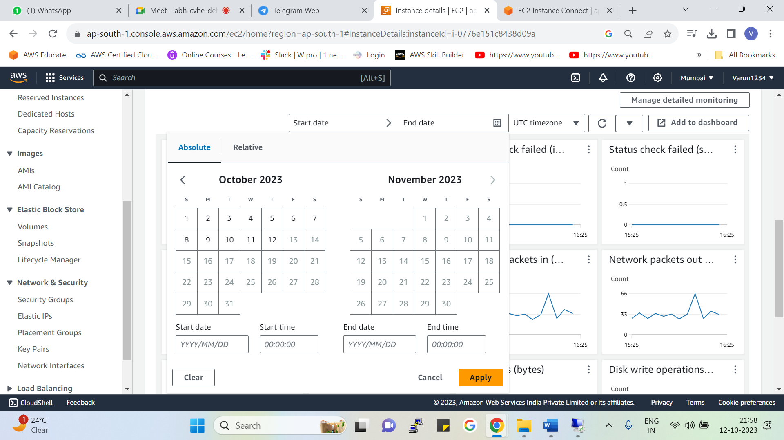



In absolute we can select specific dates and the time for which we want metrics

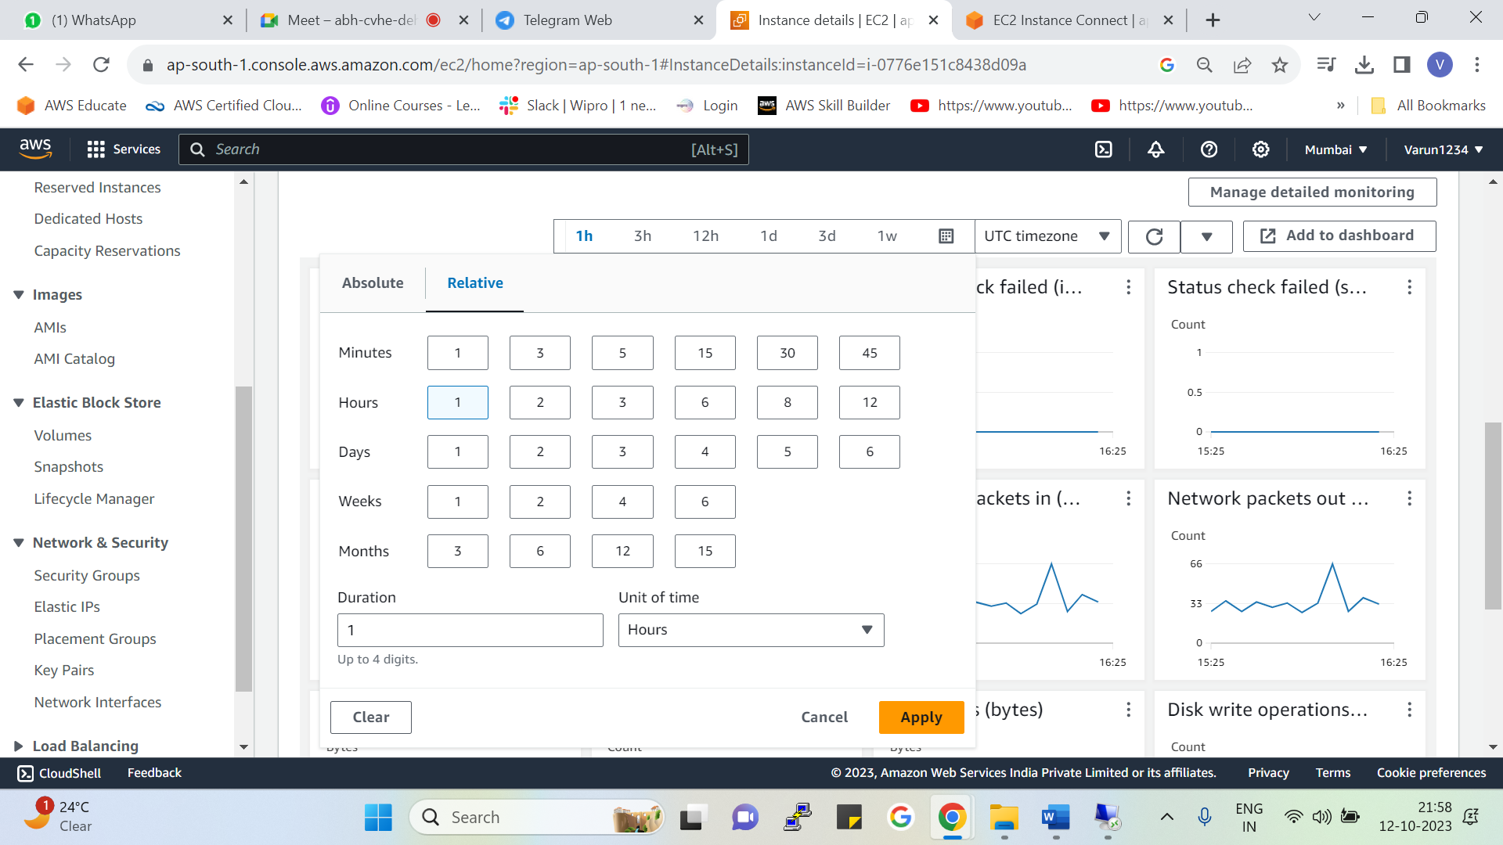



In relative we will get metrics up to 15 months here we can also get metrics based on hours, mins, days, and weeks we can also select custom metrics

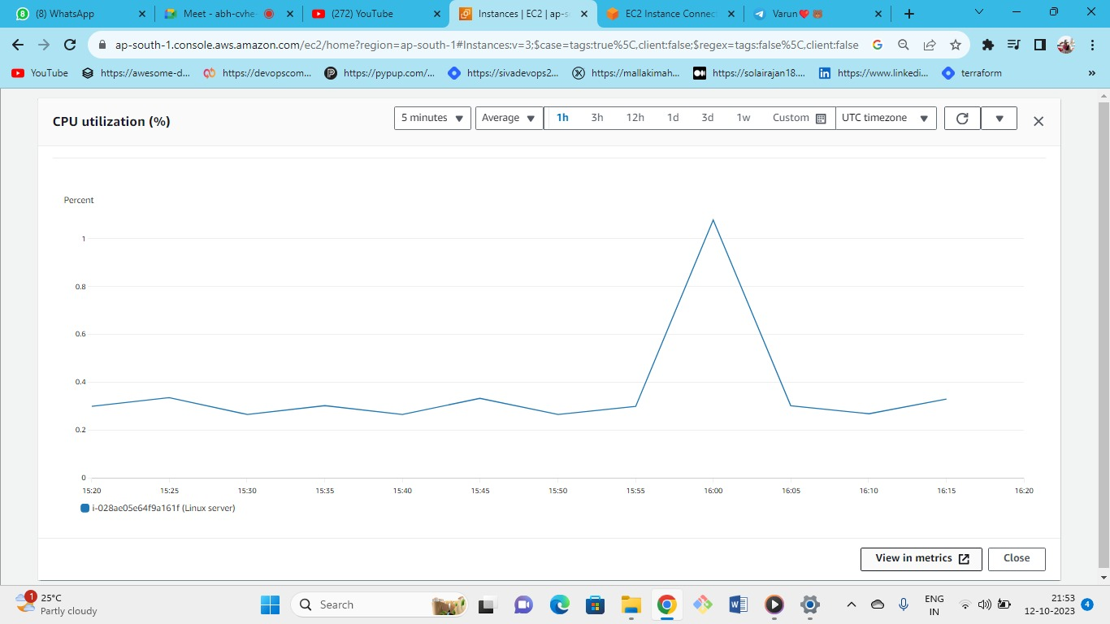

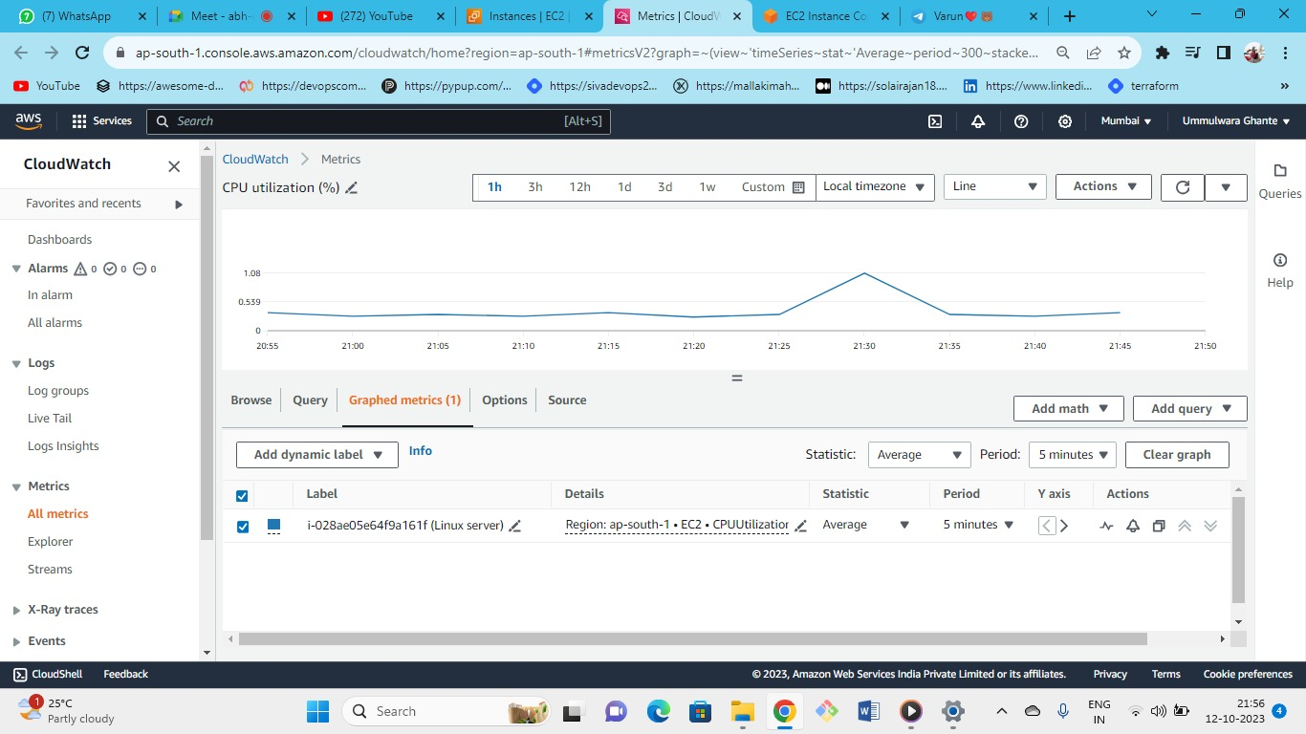



You can set the alarms for specific metrics also.

From CPU utilization🡪 view detailed metrics🡪 on the bottom bell icon we can also create an alarm from here.

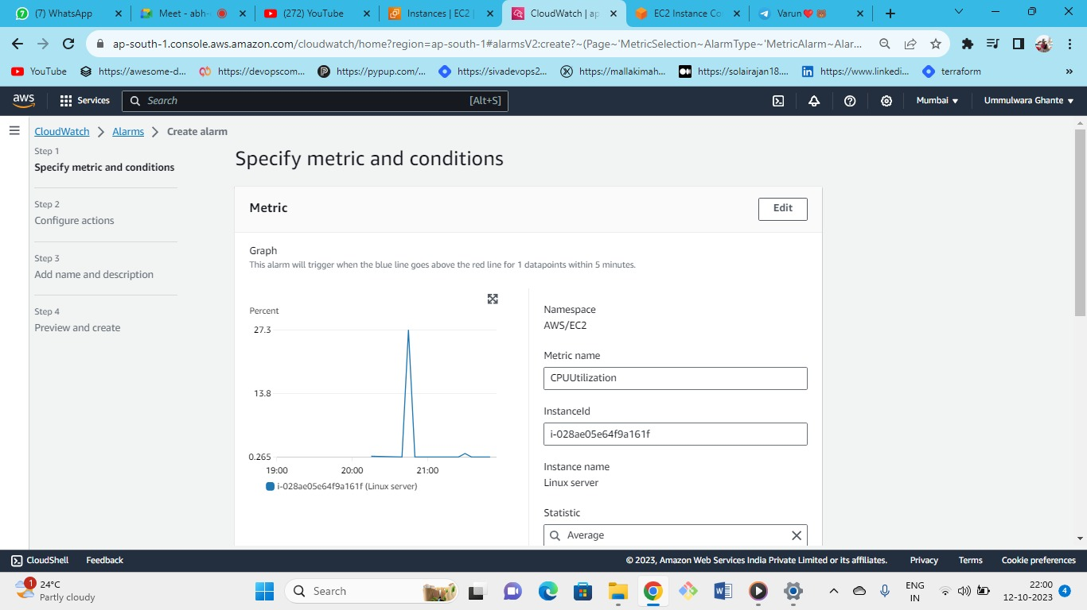



Give the metrics name and instance ID

* AWS/ec2 namespace is nothing but the folder like in AWS /ec2 folder is there.
* AWS is creating its own folder to store default metrics
* it is AWS provided name space(AWS/EC2)

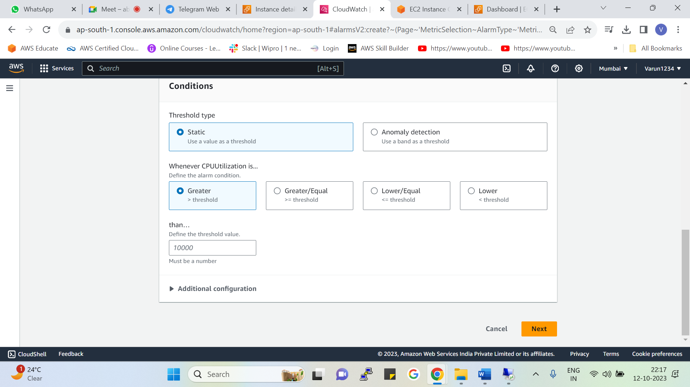



Here you need to just fill the details for detailed monitoring

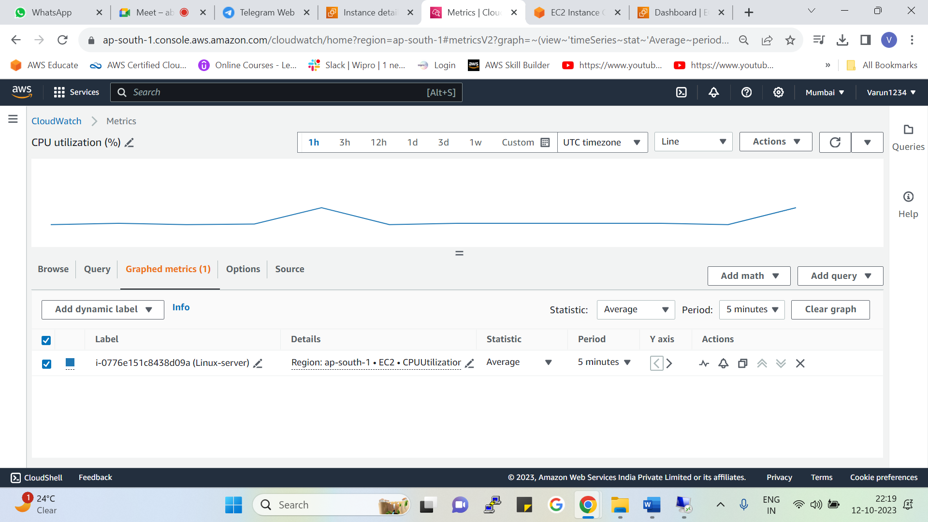



As you can see this is graphics monitoring which we are specifically monitoring for the CPU Utilization of our ec2 instance

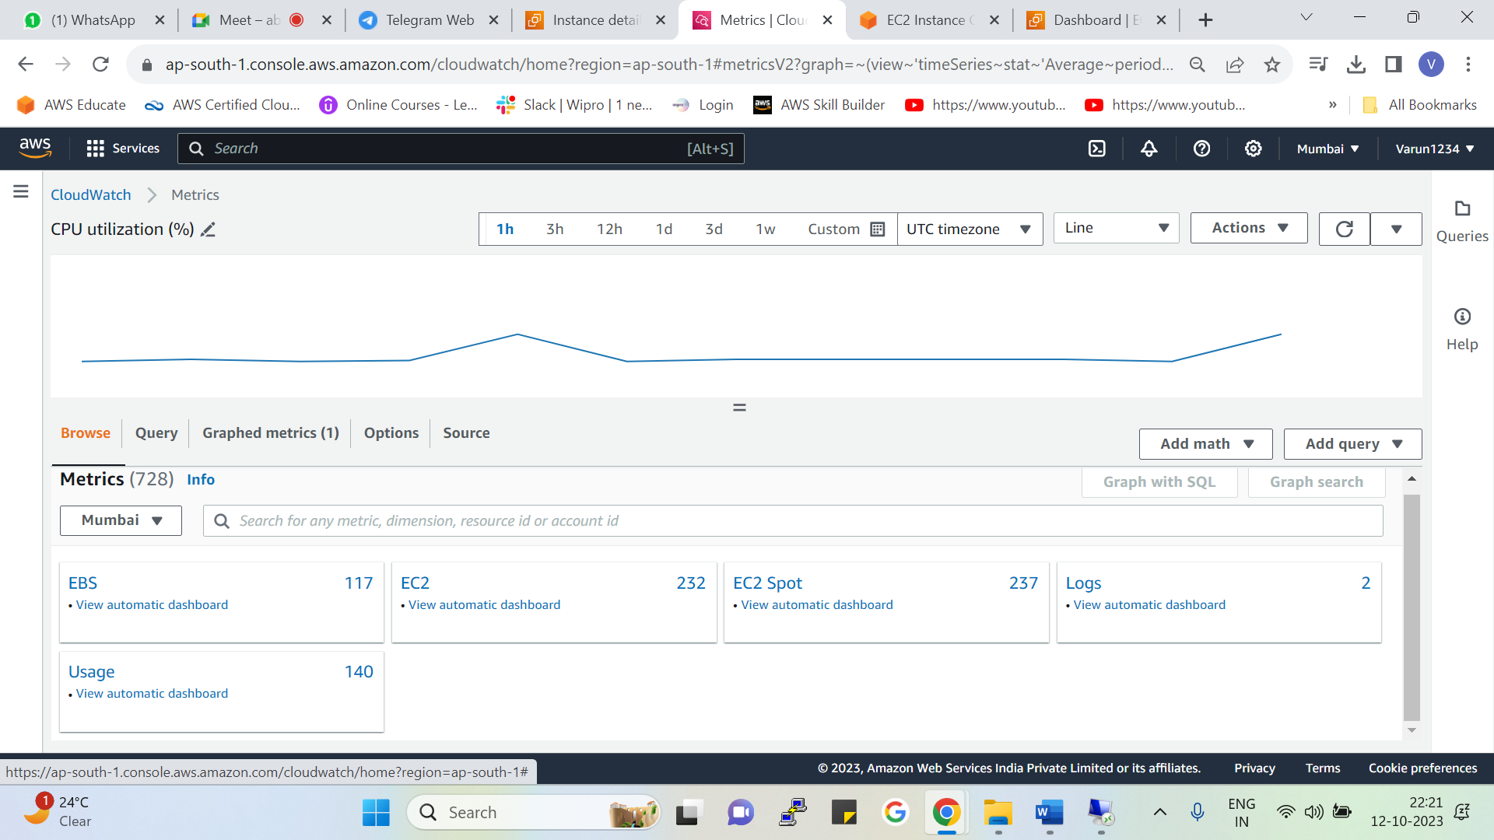



If we browse, we will get multiple sections from AWS

These are the AWS provided namespaces

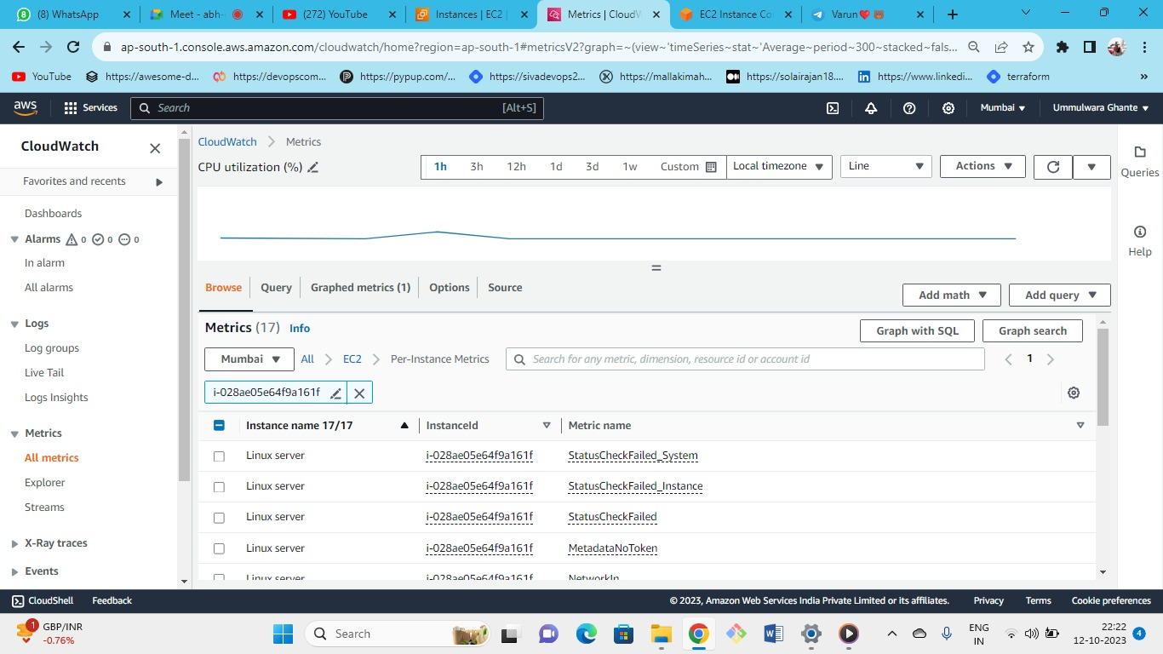



we will get metrics related to this instance id.

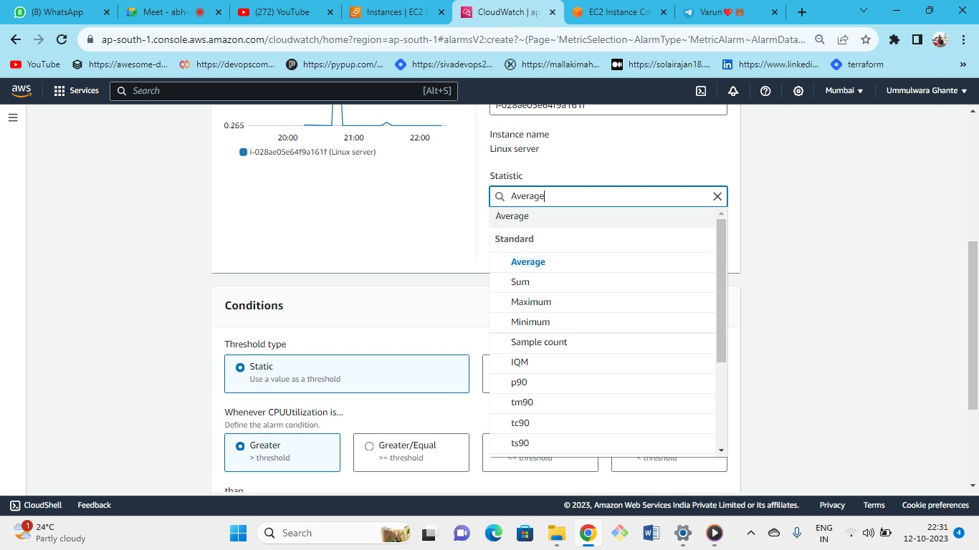



* statistics is nothing but on what basis you are calculating
* generally, we use statistics as an average to avoid momentarily triggering the alarms and to avoid false alarms so it will take an average of all the data points for the specific period and then will give the metric so that false alarms are not triggered.
* Following are the type of metrics count that are available for the metric

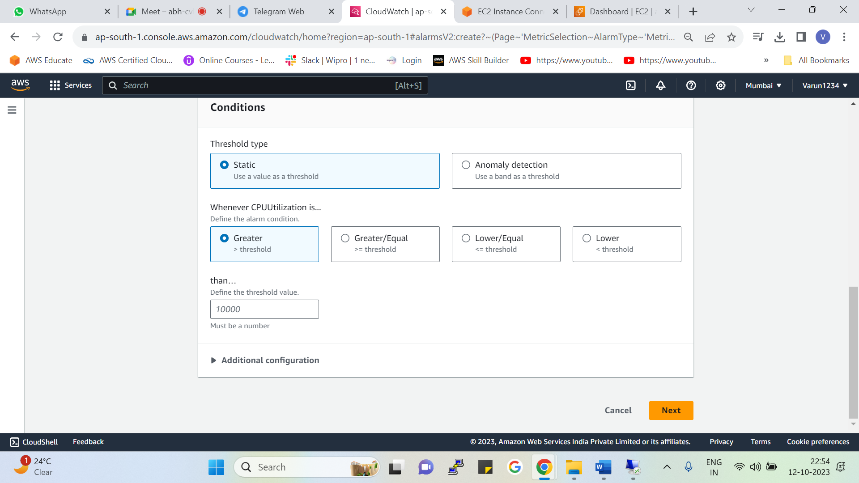



**Here we select the conditions in which we want to trigger an alarm.**

**Based on the conditions the metrics are triggered**

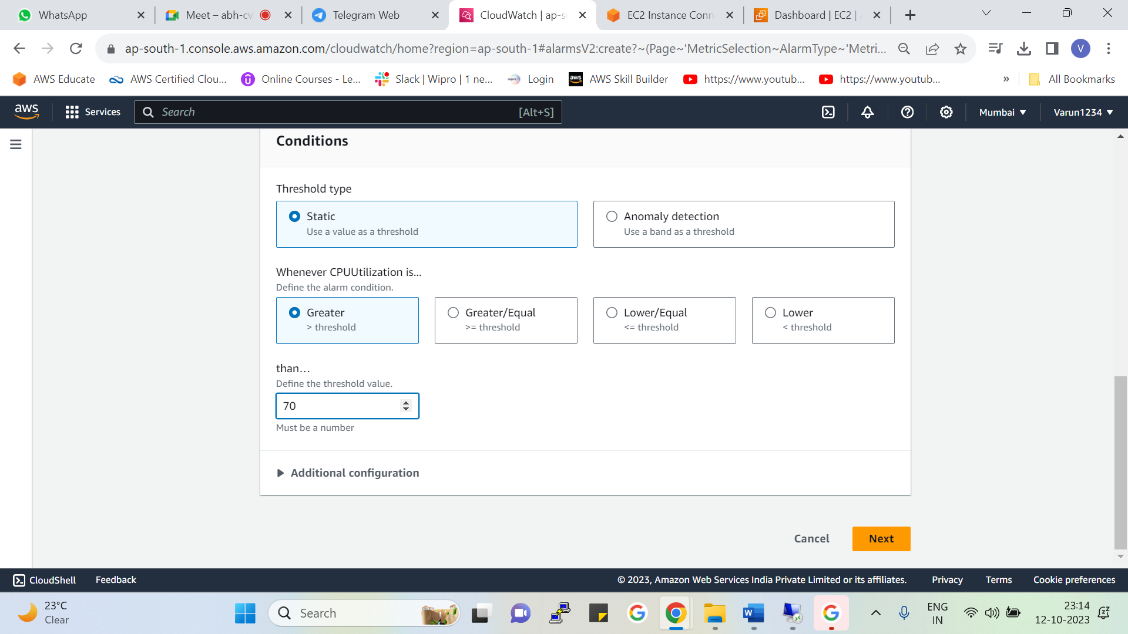



1. **Static—**will use threshold limit value where the alarm will get triggered.

Here we have the exact threshold value

i.e. alarm will trigger if <70

1. **Anomaly detection-** here we use the band of threshold (i.e. in between that range or excluding that range there is no exact value e.g. I do not want avg between 50-70 I want more than 70 or less than 50 so we will get it by selecting( greater than <70 , lower than >30 or outside the band <70and >30)

Here we select the specific range of values

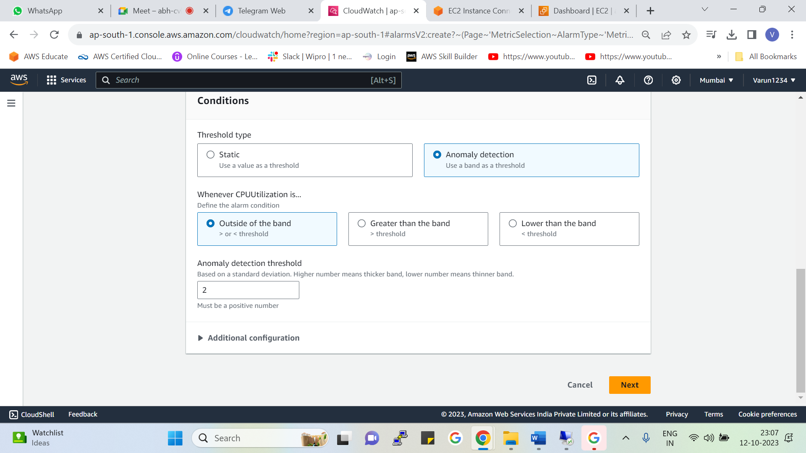



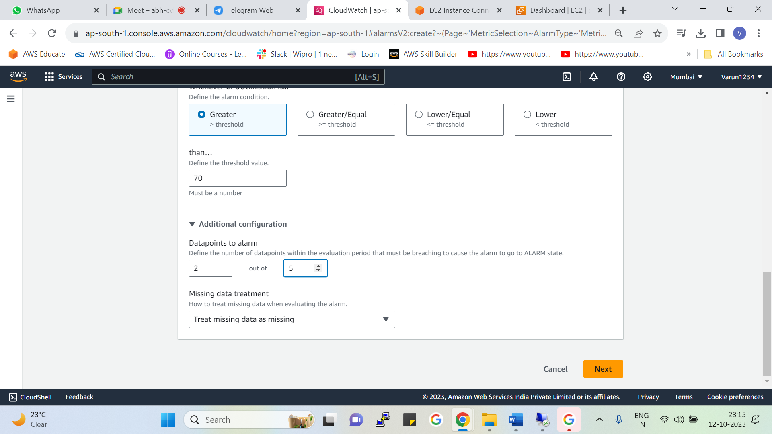



* Here we select the no of data points to trigger an alarm
* 2 out of 5 means 🡪 as we have selected, we need an average of every 1 min and the threshold we have selected is 70
* So it will collect the average of every 1 min for 5 data points and in that 5 data points if the value crosses the threshold 2 times then the alarm will trigger.

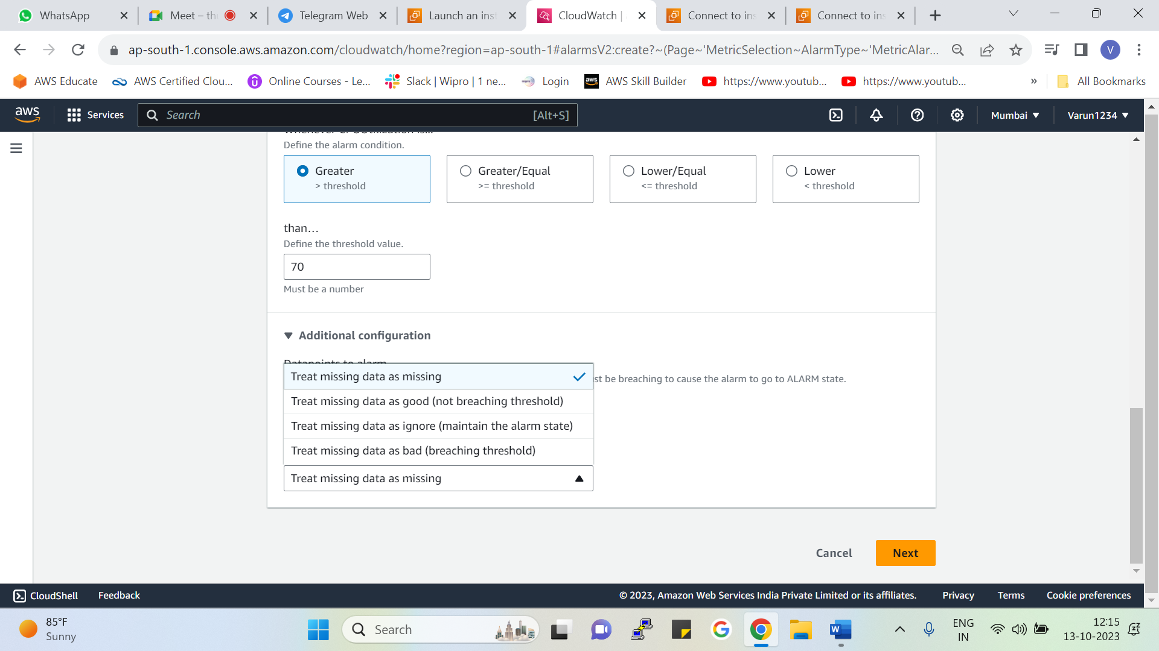



Following are the options we need to select if the data is missing for some data points what shall AWS consider to trigger an alarm.

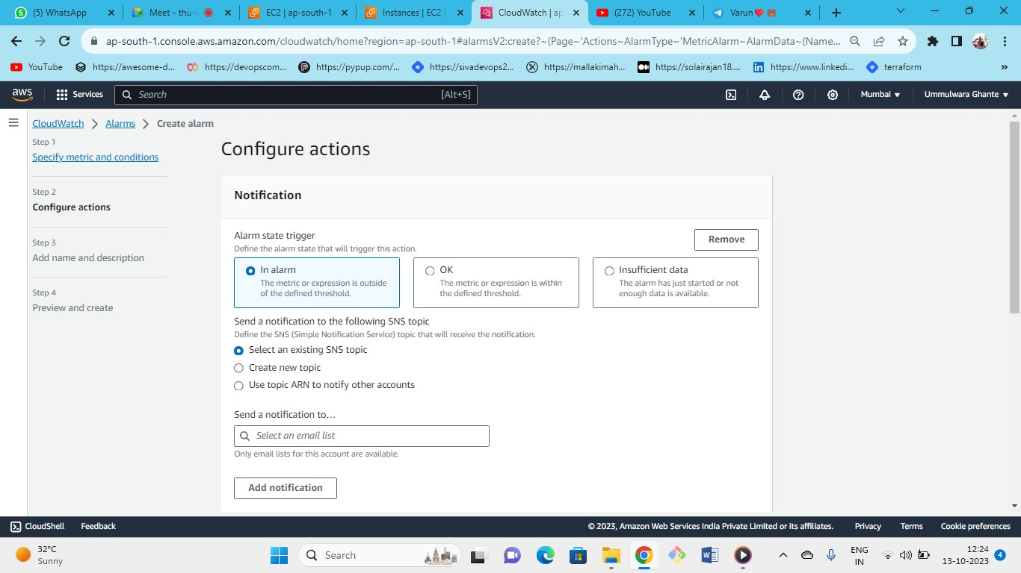



In each state we can get the notification.

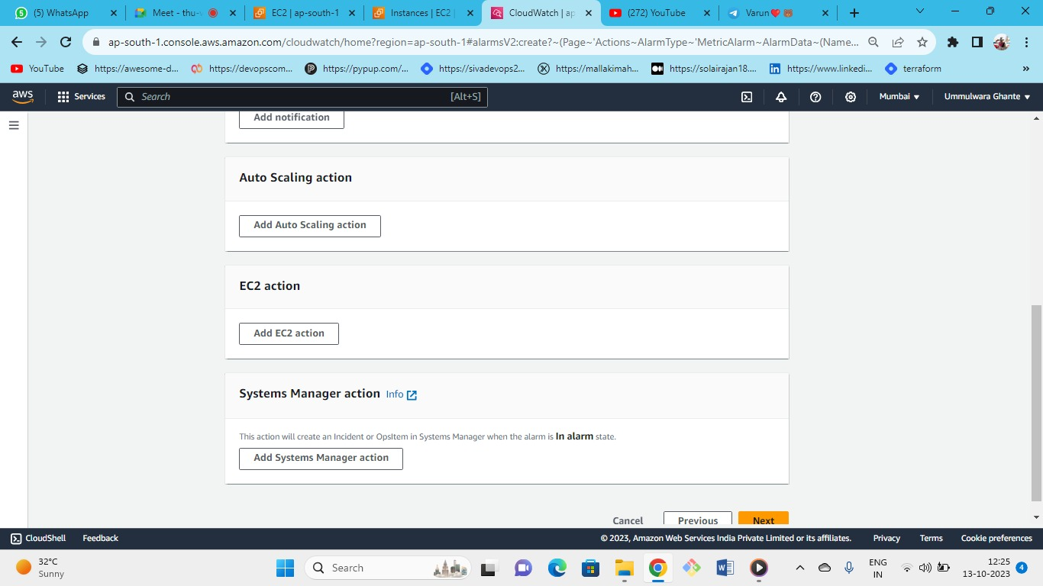



Following are the alarm action types of ec2 which we can set for different alarm types (i.e. OK, insufficient data and alarm state)

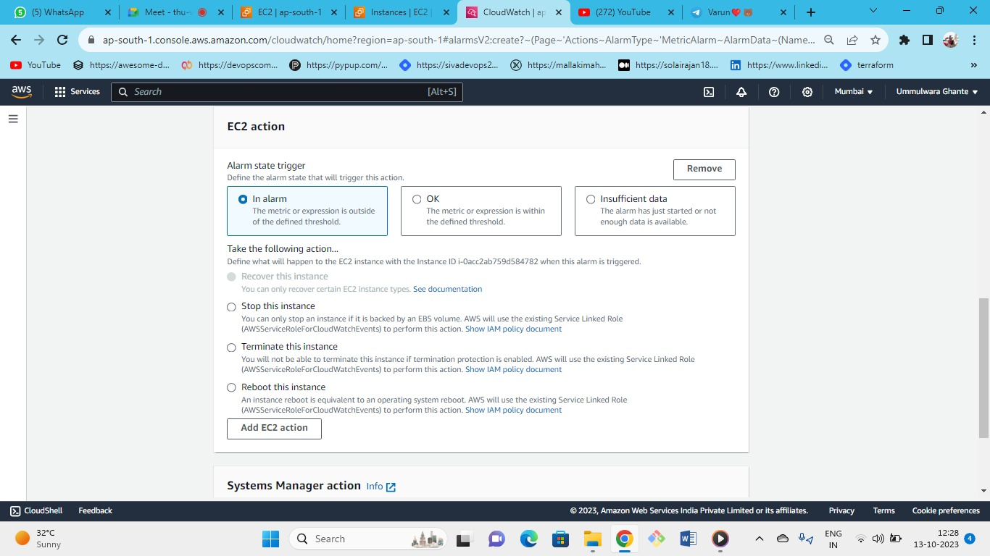



* As we can see this is an ec2 alarm action we can (stop, reboot or terminate the instance)
* Also for some type of instances we can recover the instance

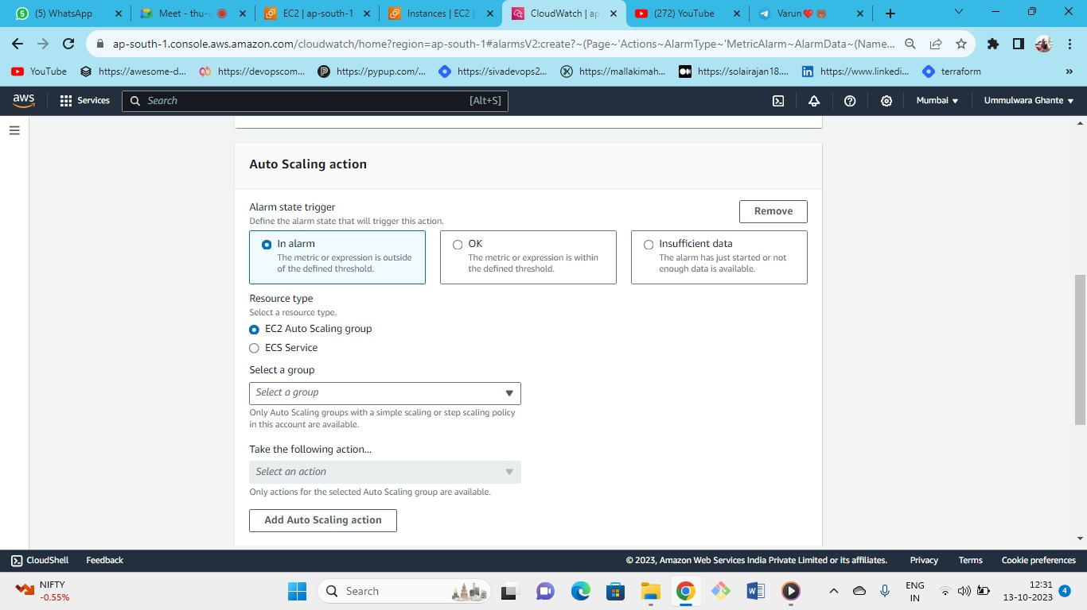



* Following is an alarm action for auto scaling we can auto scale for ec2 or by using ECS container service.

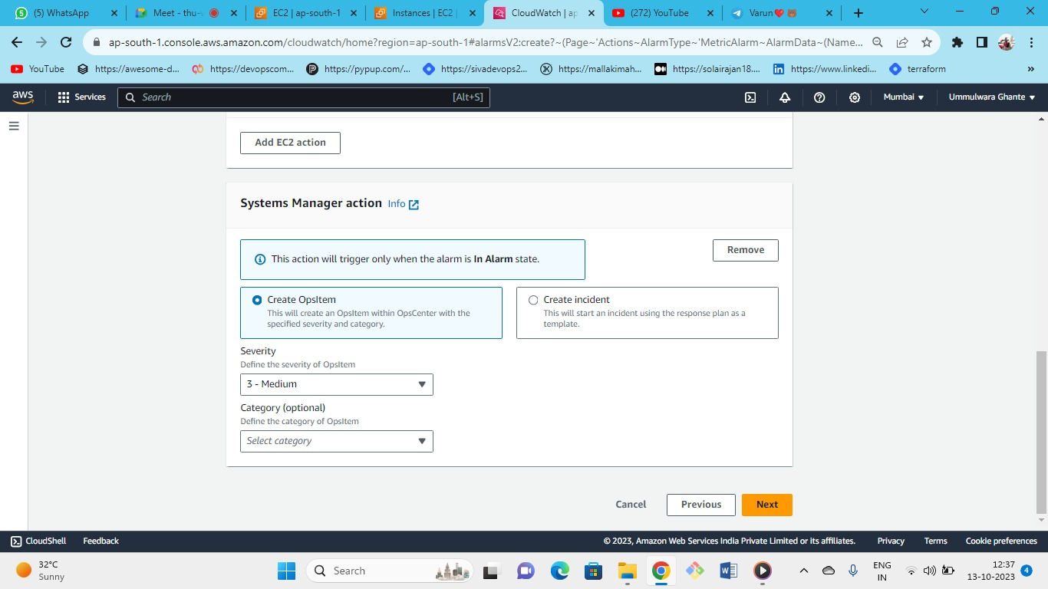



Can use for implementing some custom actions

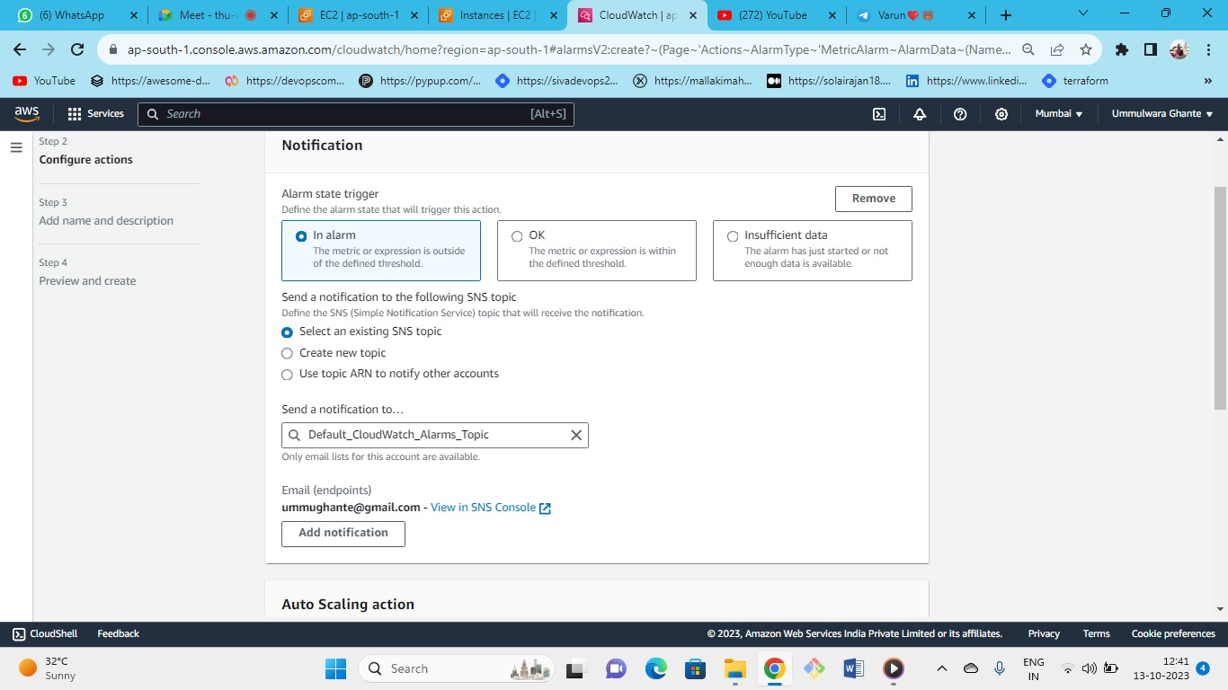



* You can create or use existing SNS topic
* **Note : after creating SNS topic make sure to register it with your email**
* So lets create and set an alarm

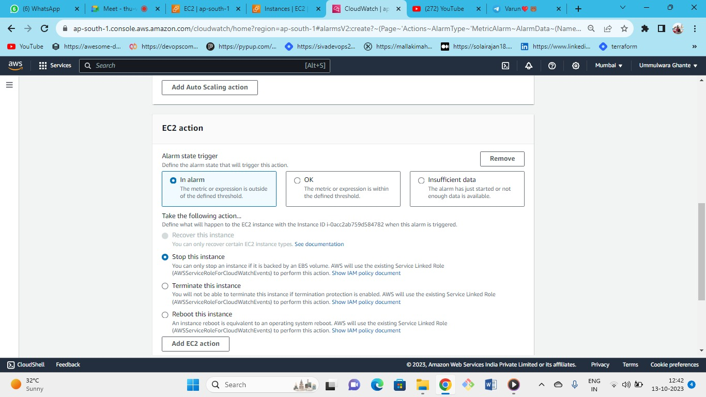



From here you can define an action that AWS has to take if alarm has been triggered such as you can (stop, terminate or reboot the instance)

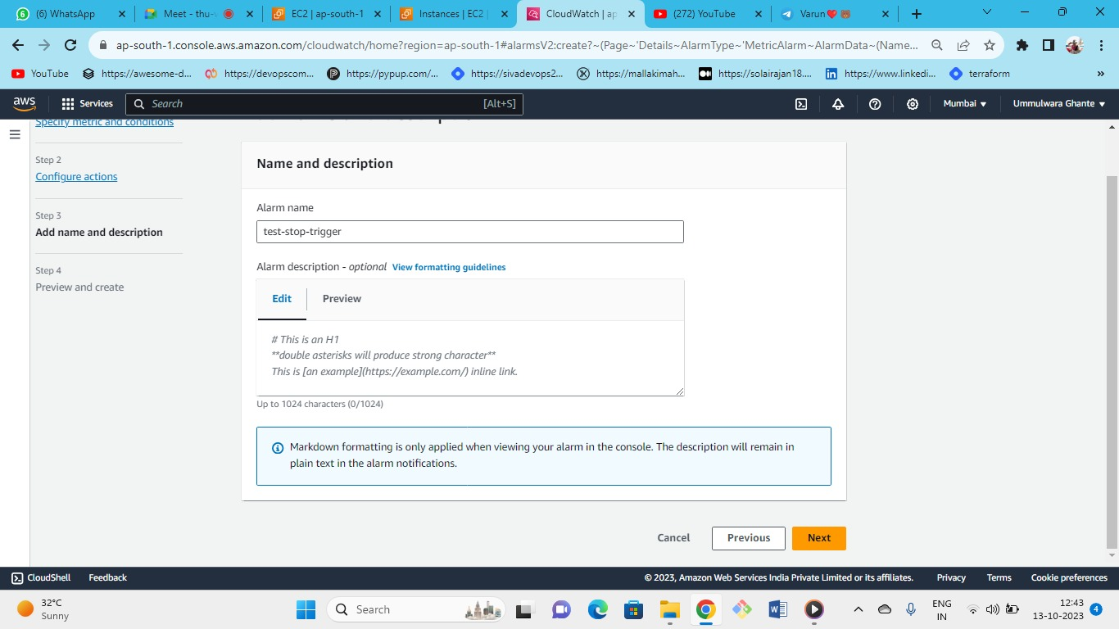



Give alarm name and click next

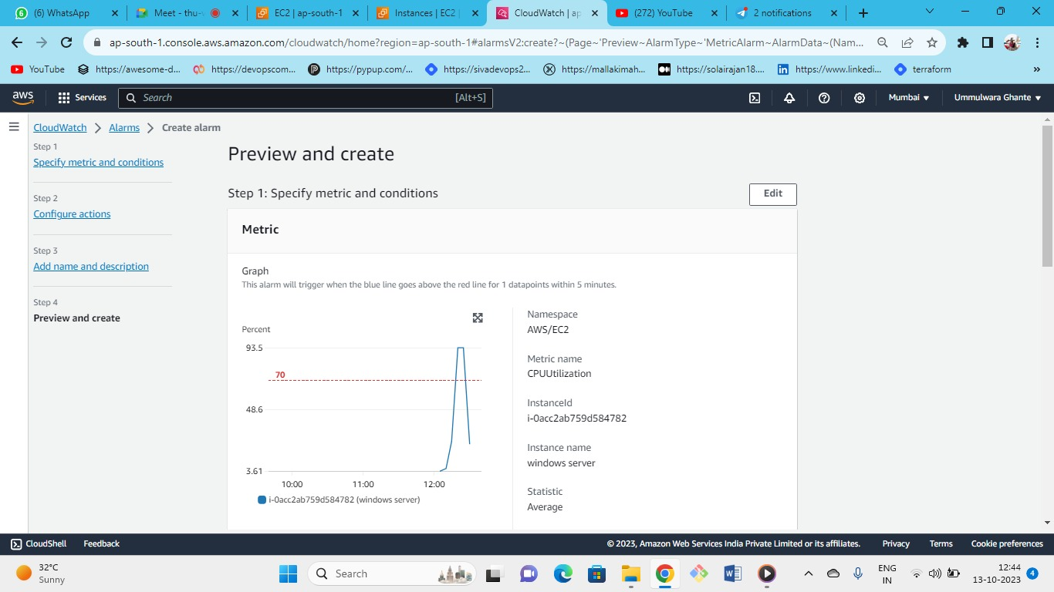



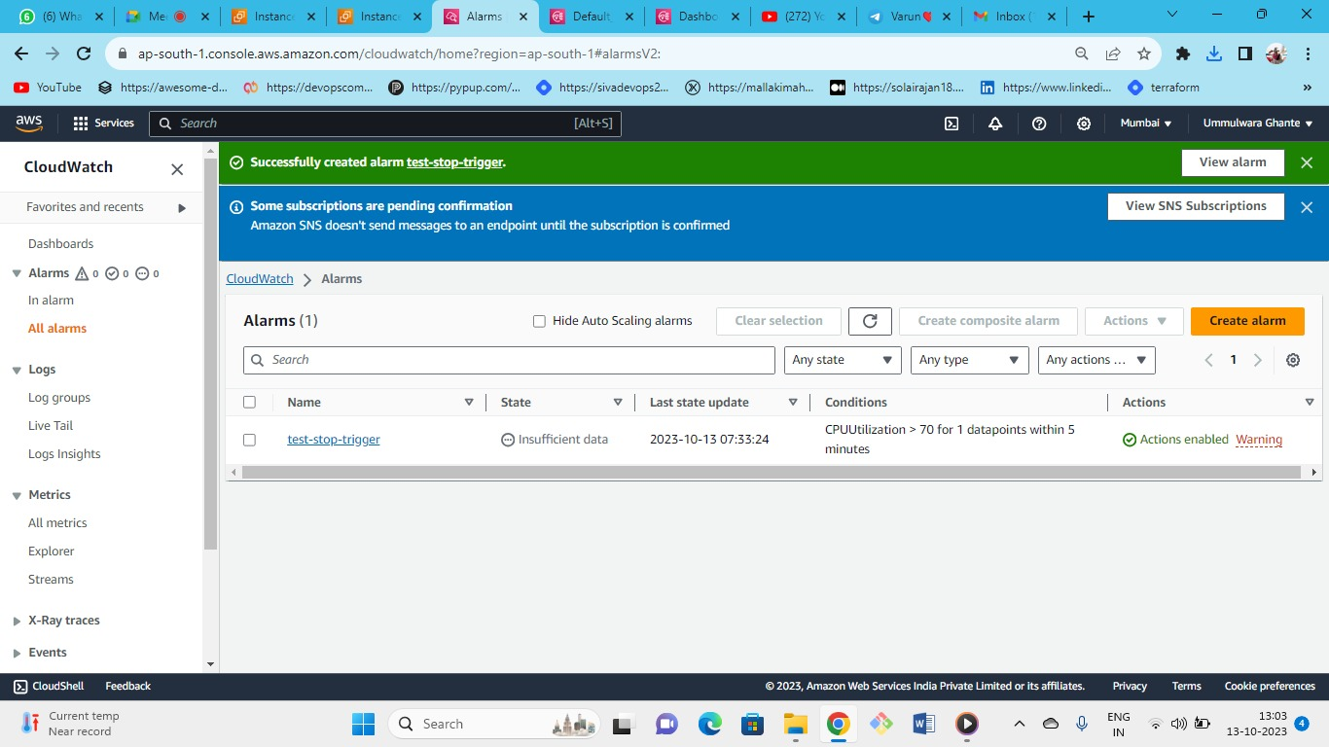



* Alarm created successfully for CPU Utilization of instance
* **Amazon SNS.**

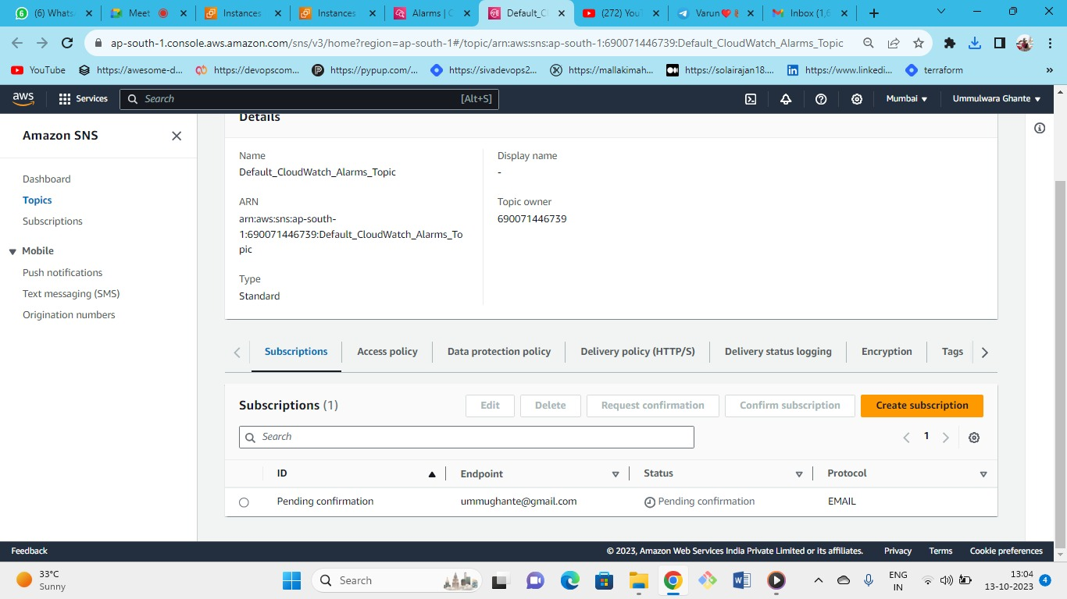



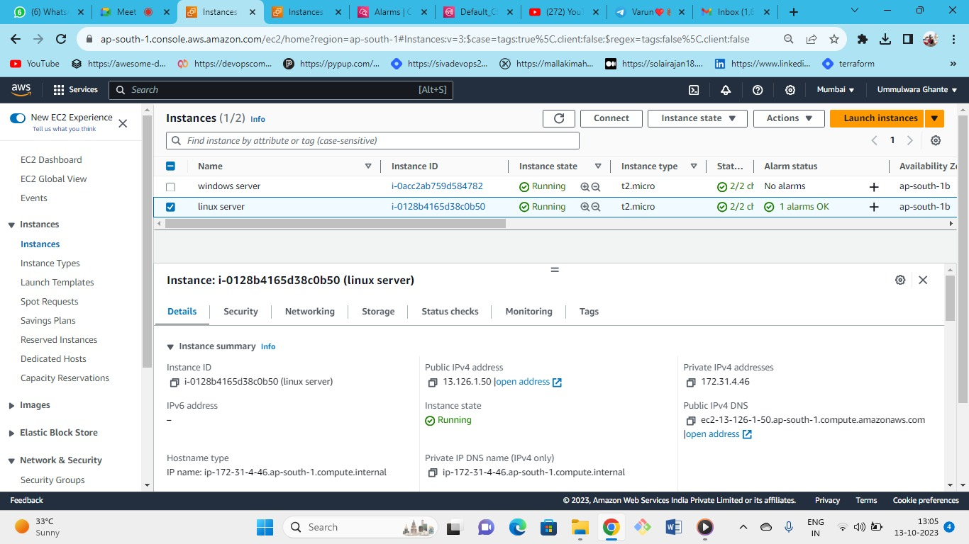



On Linux server as we can see we have an alarm with status OK so we need to trigger an alarm for testing purpose.

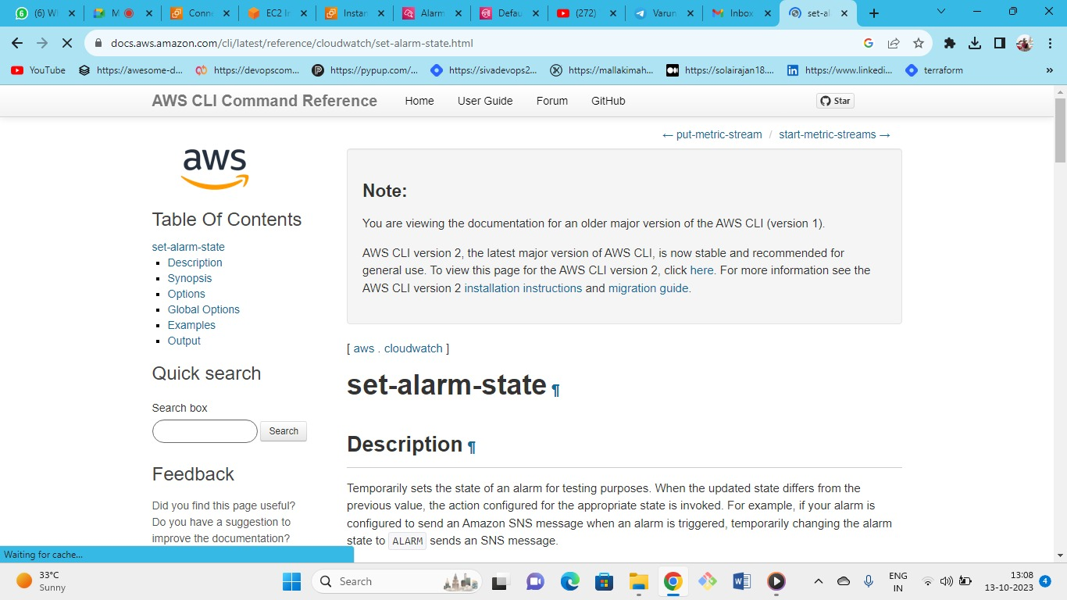

So by referring following documentation of AWS we will get the query for cli to trigger alarm for testing purpose.

[https://docs.AWS.amazon.com/cli/latest/reference/cloudwatch/set-alarm-state.html](https://docs.aws.amazon.com/cli/latest/reference/cloudwatch/set-alarm-state.html)

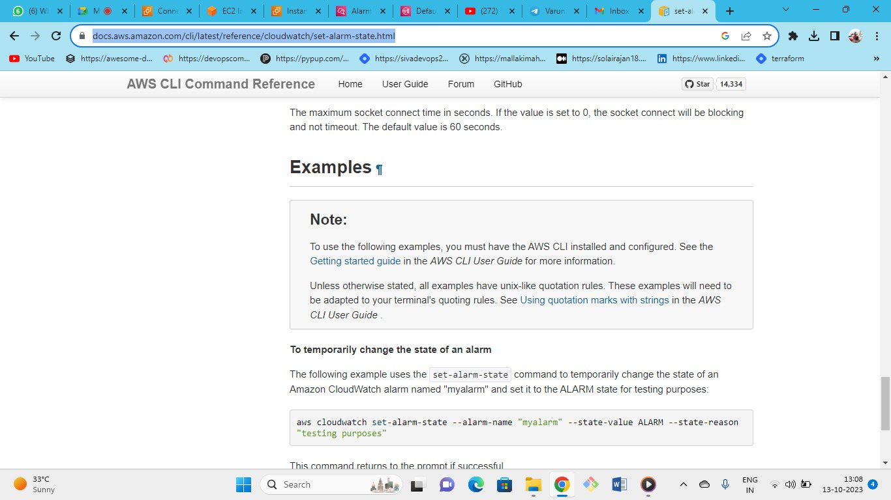

This is the query we need to enter the linux server cli **just change the alarm name\**

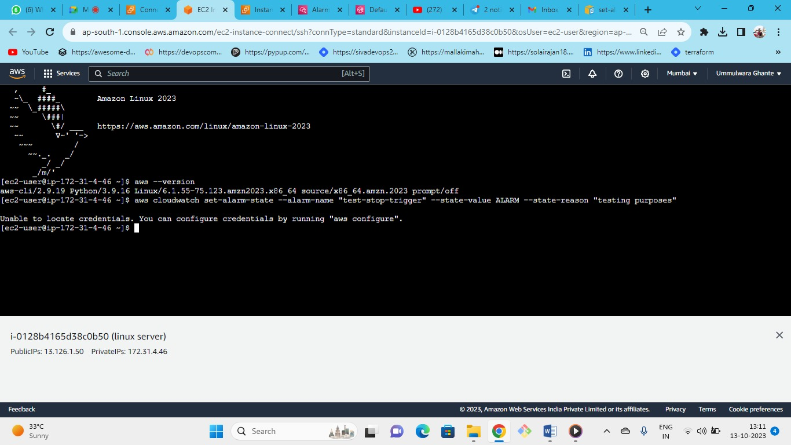



As we can see we need to configure AWS

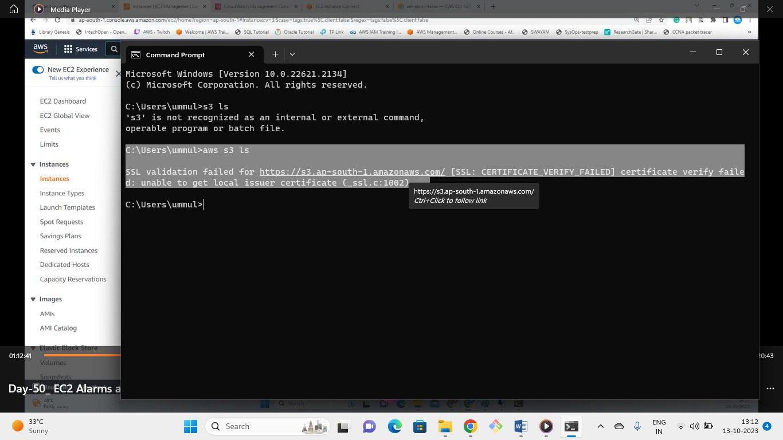



We cant get details of s3 without configuring AWS

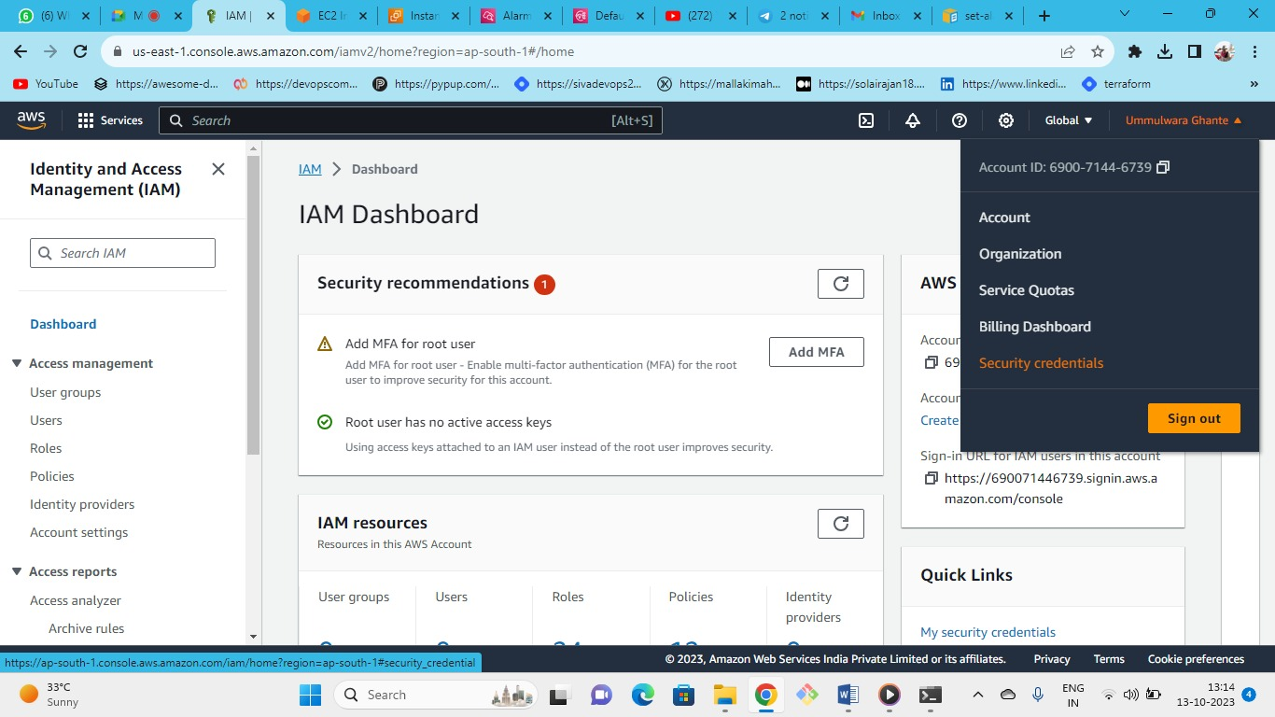



To configure AWS go to IAM

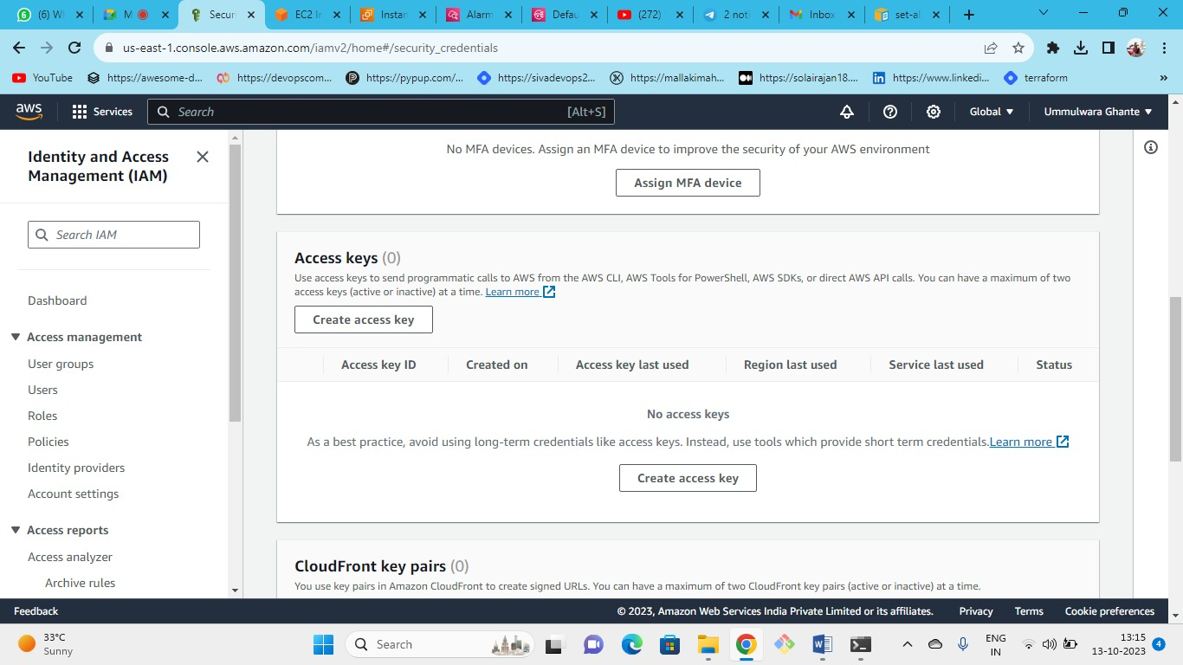



Create the access key after creating it you will also get the secret access key

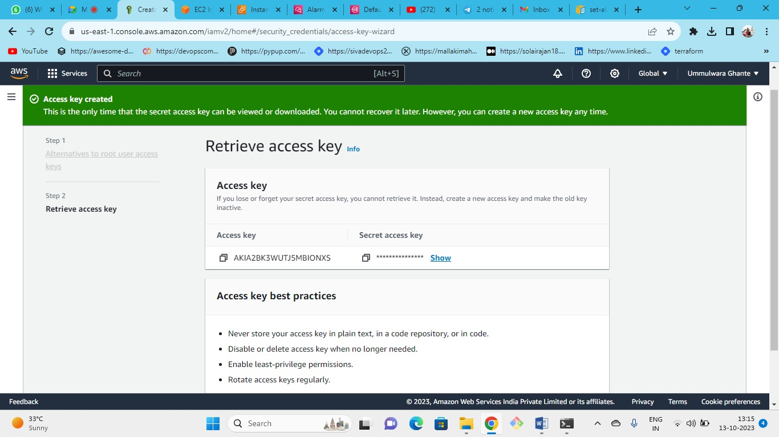



Keys Successfully created

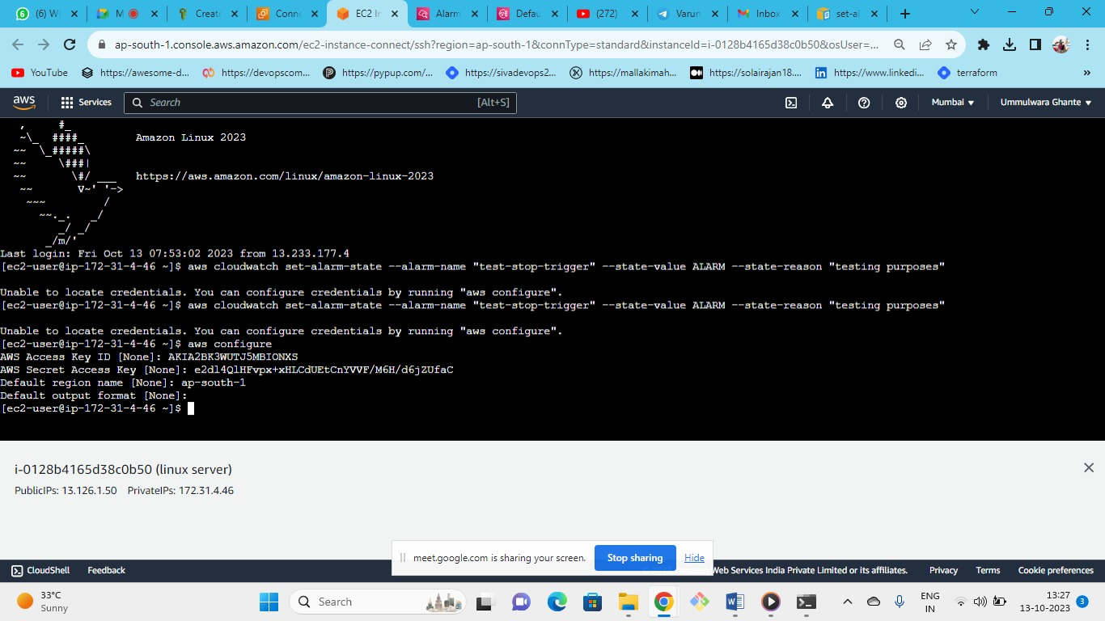



Now enter the keys and configure the AWS

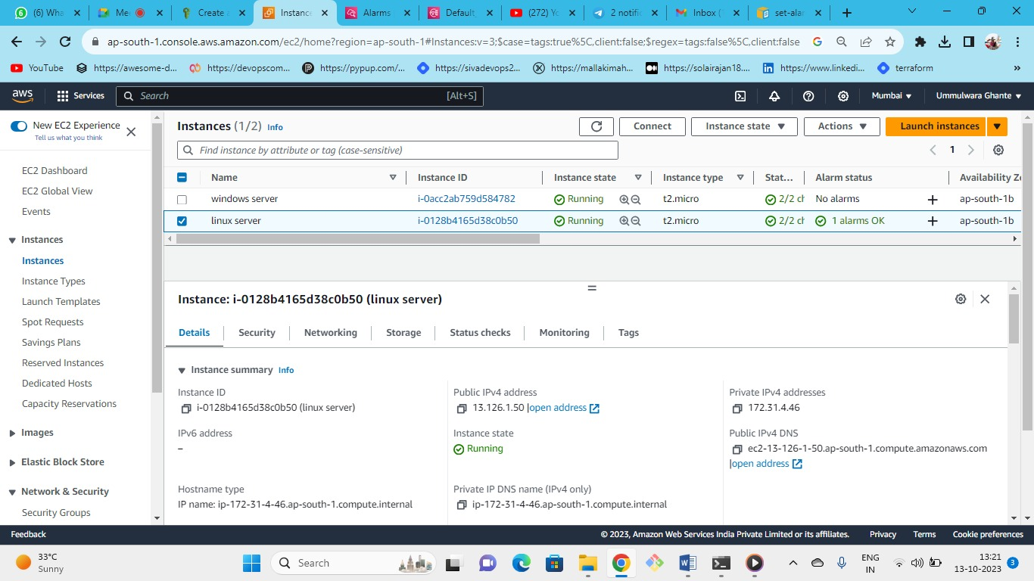



As we can see before firing the command alarm state of linux server is OK

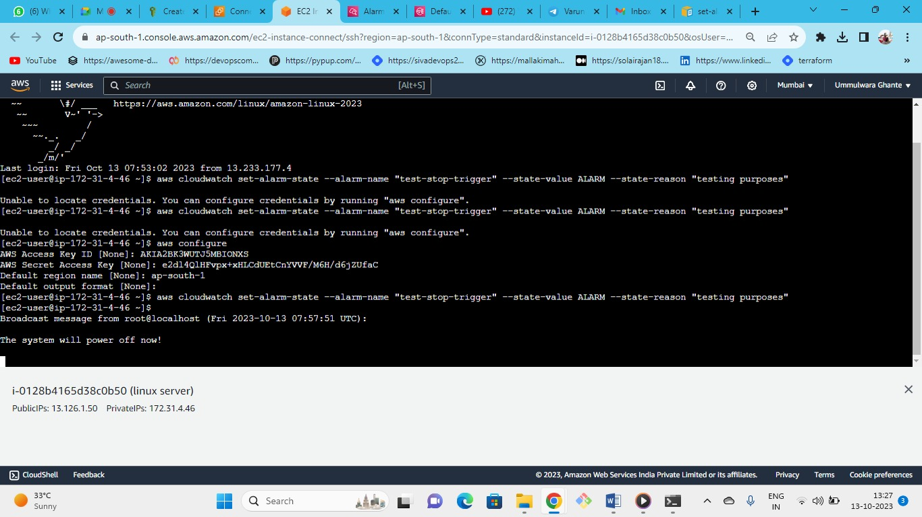



Query for alarm trigger is fired

**AWS cloudwatch set-alarm-state --alarm-name "abc" --state-value ALARM --state-reason "testing purposes"**

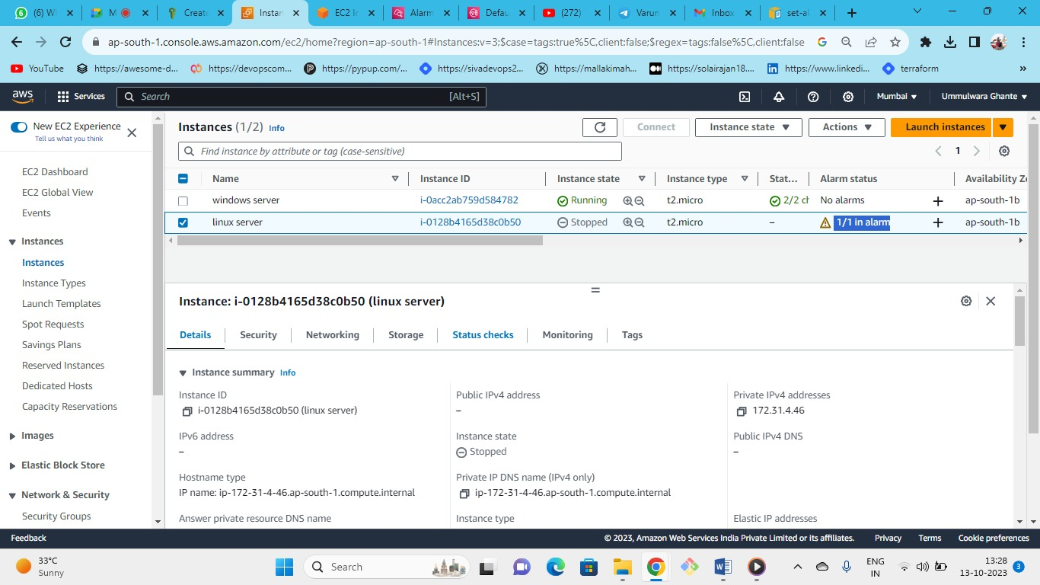



As we can see after running the query our instance is stopped.

**Cloudwatch**

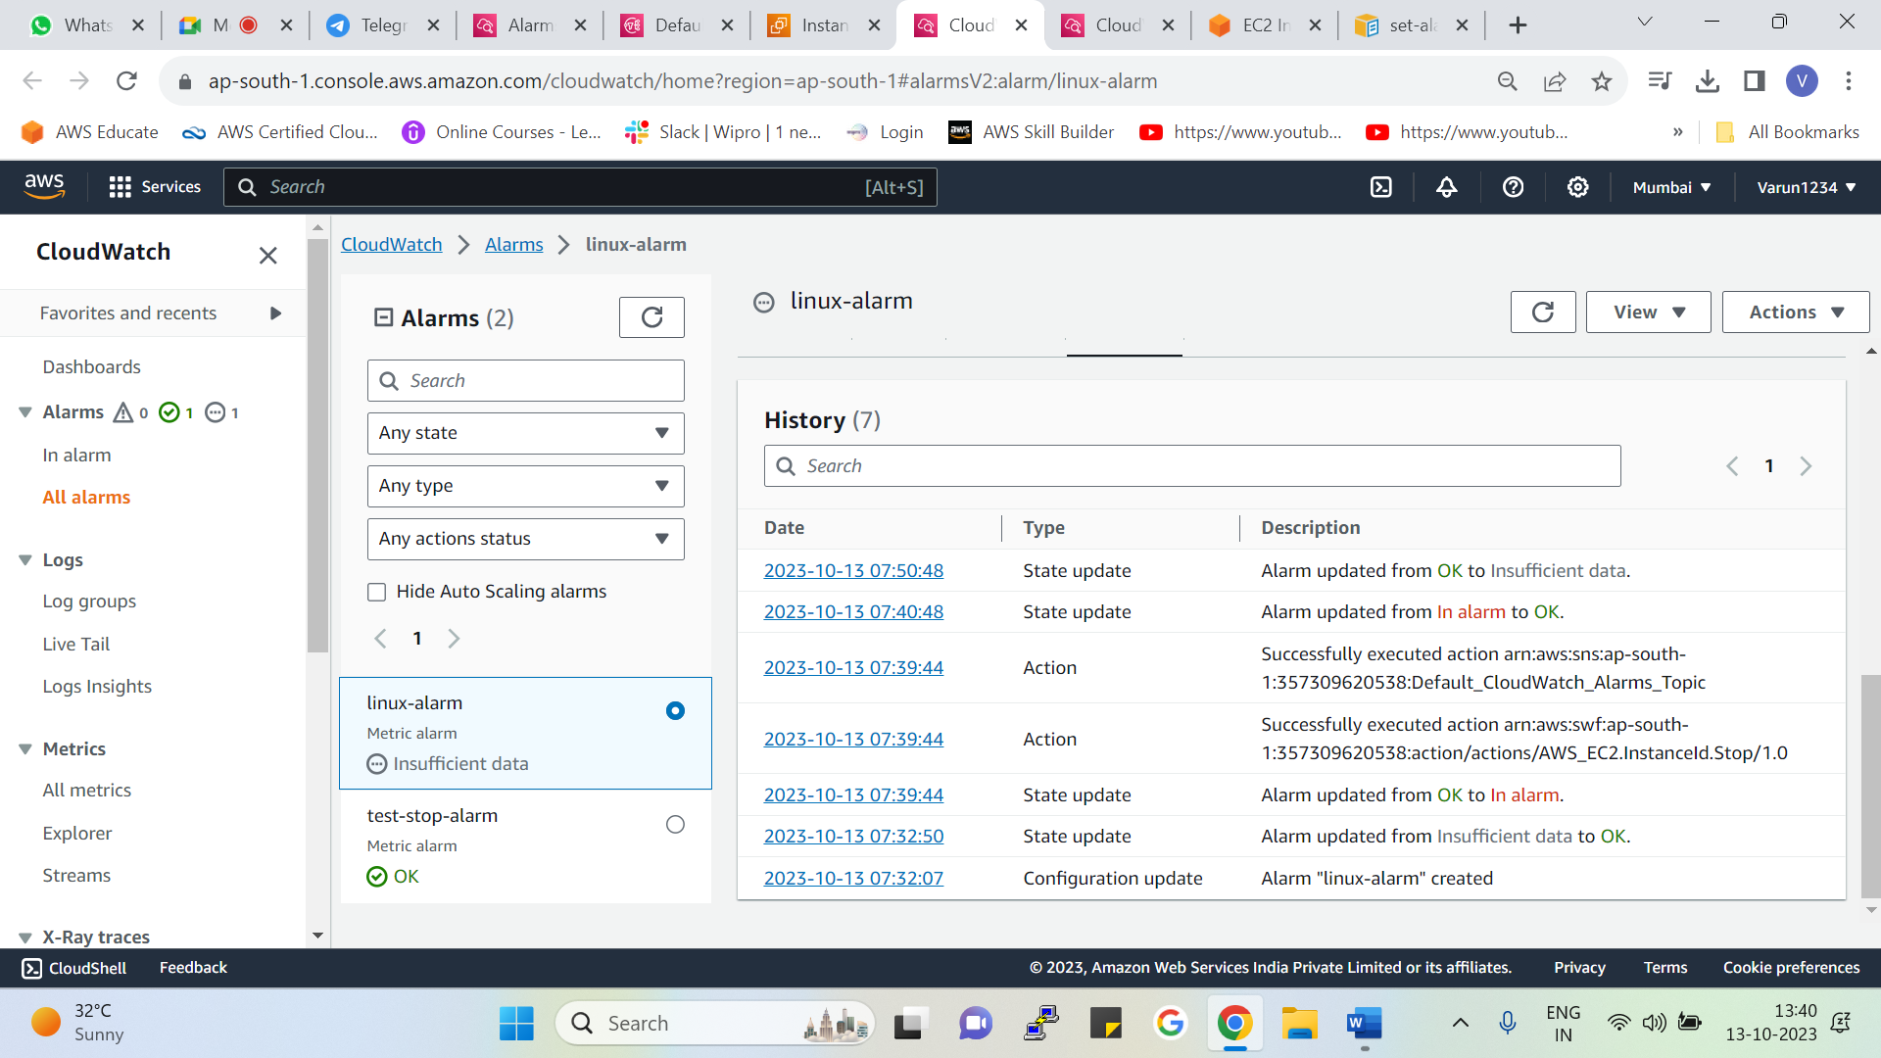



As we can see in the cloudwatch event history

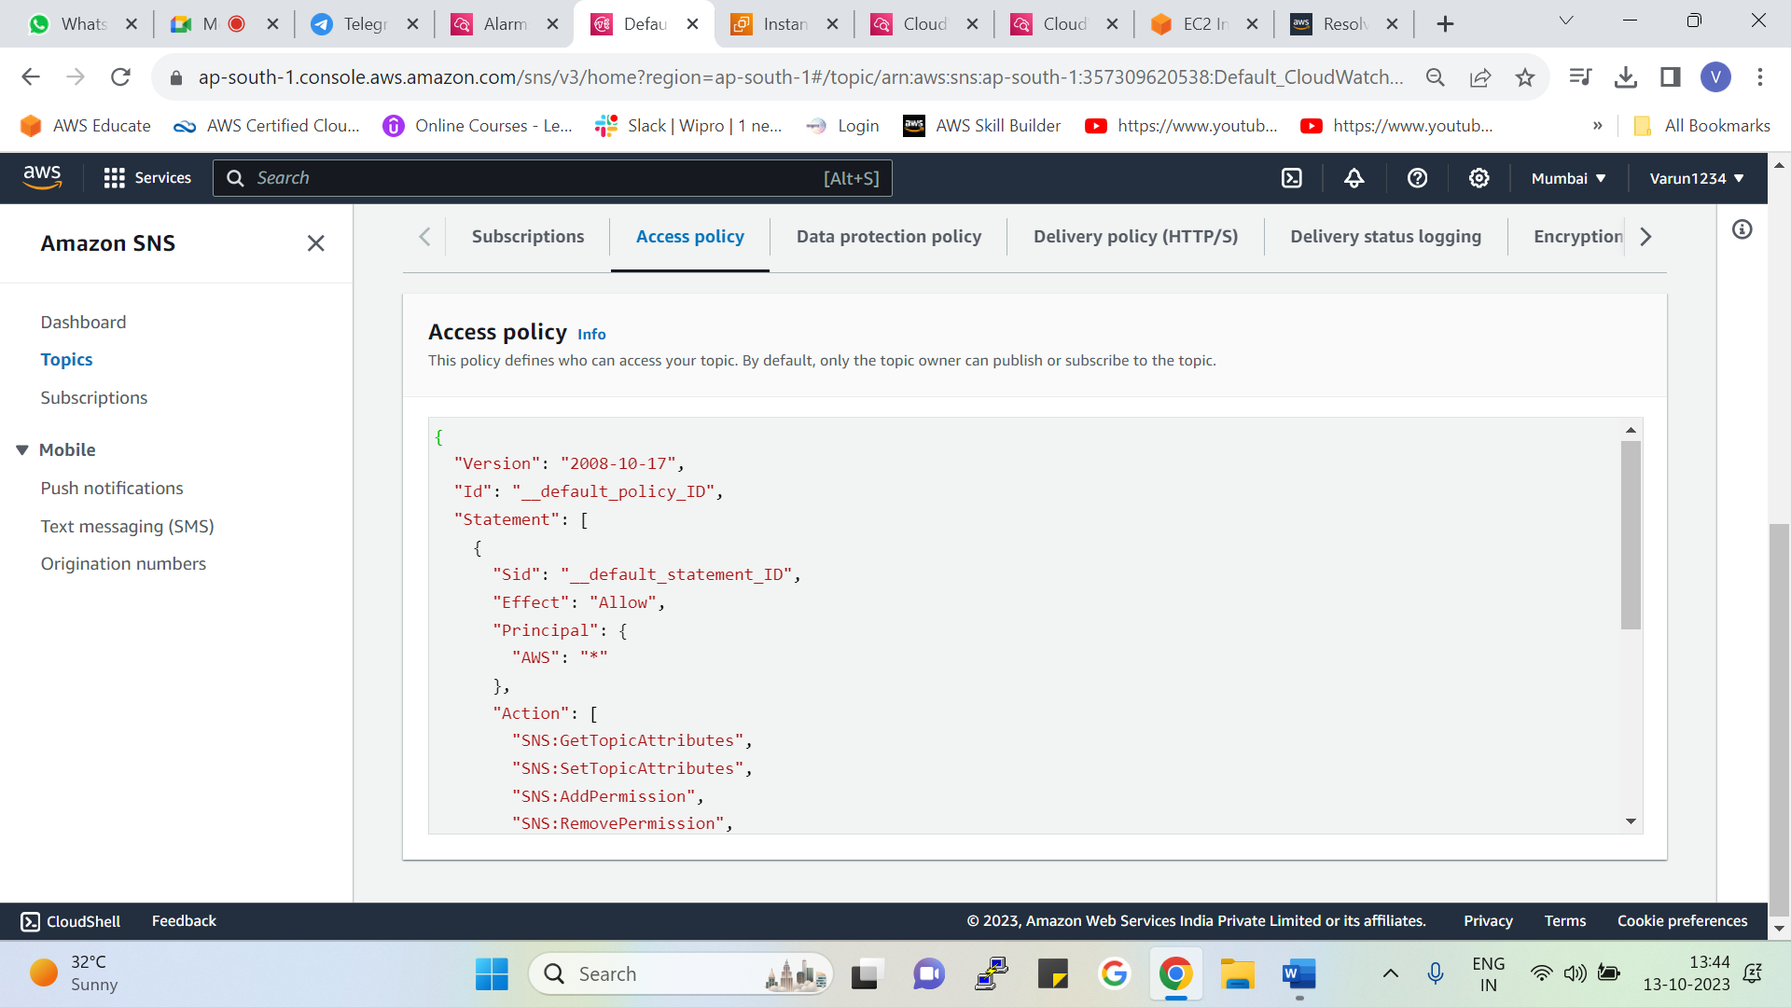



* In the SNS the topic you have created check the access policy
* [https://repost.AWS/knowledge-center/cloudwatch-receive-SNS-for-alarm-trigger](https://repost.aws/knowledge-center/cloudwatch-receive-sns-for-alarm-trigger)
* go on the following link and copy the access policy permission for cloudwatch SNS

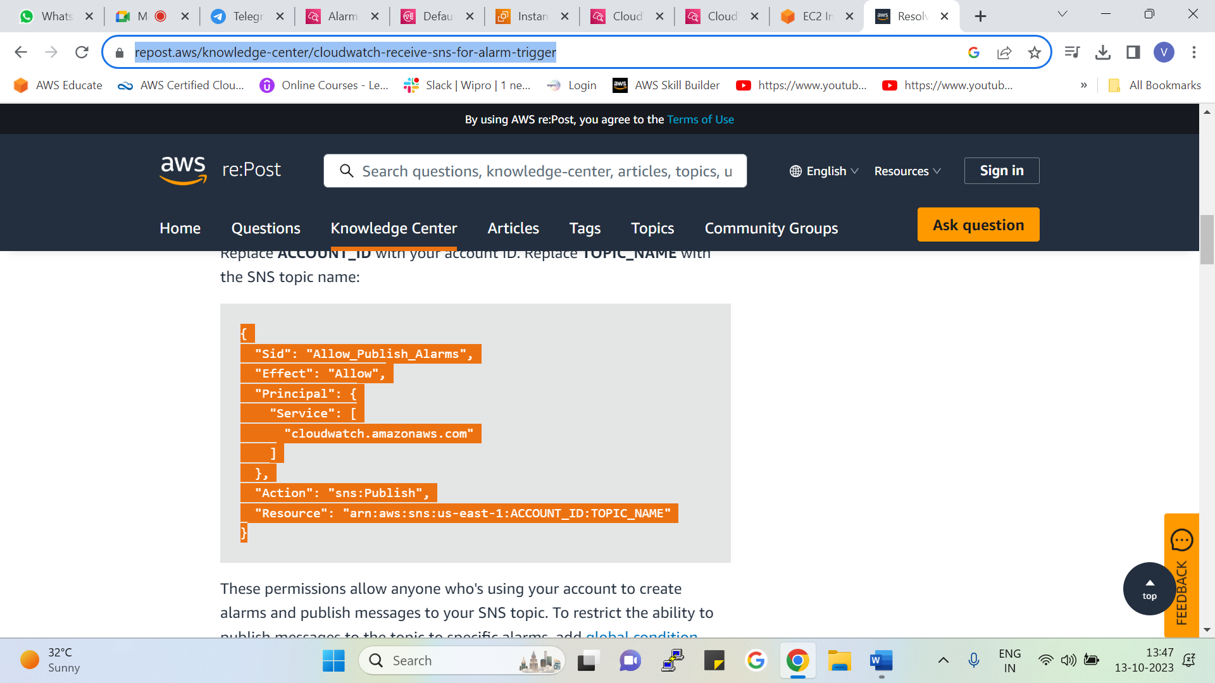

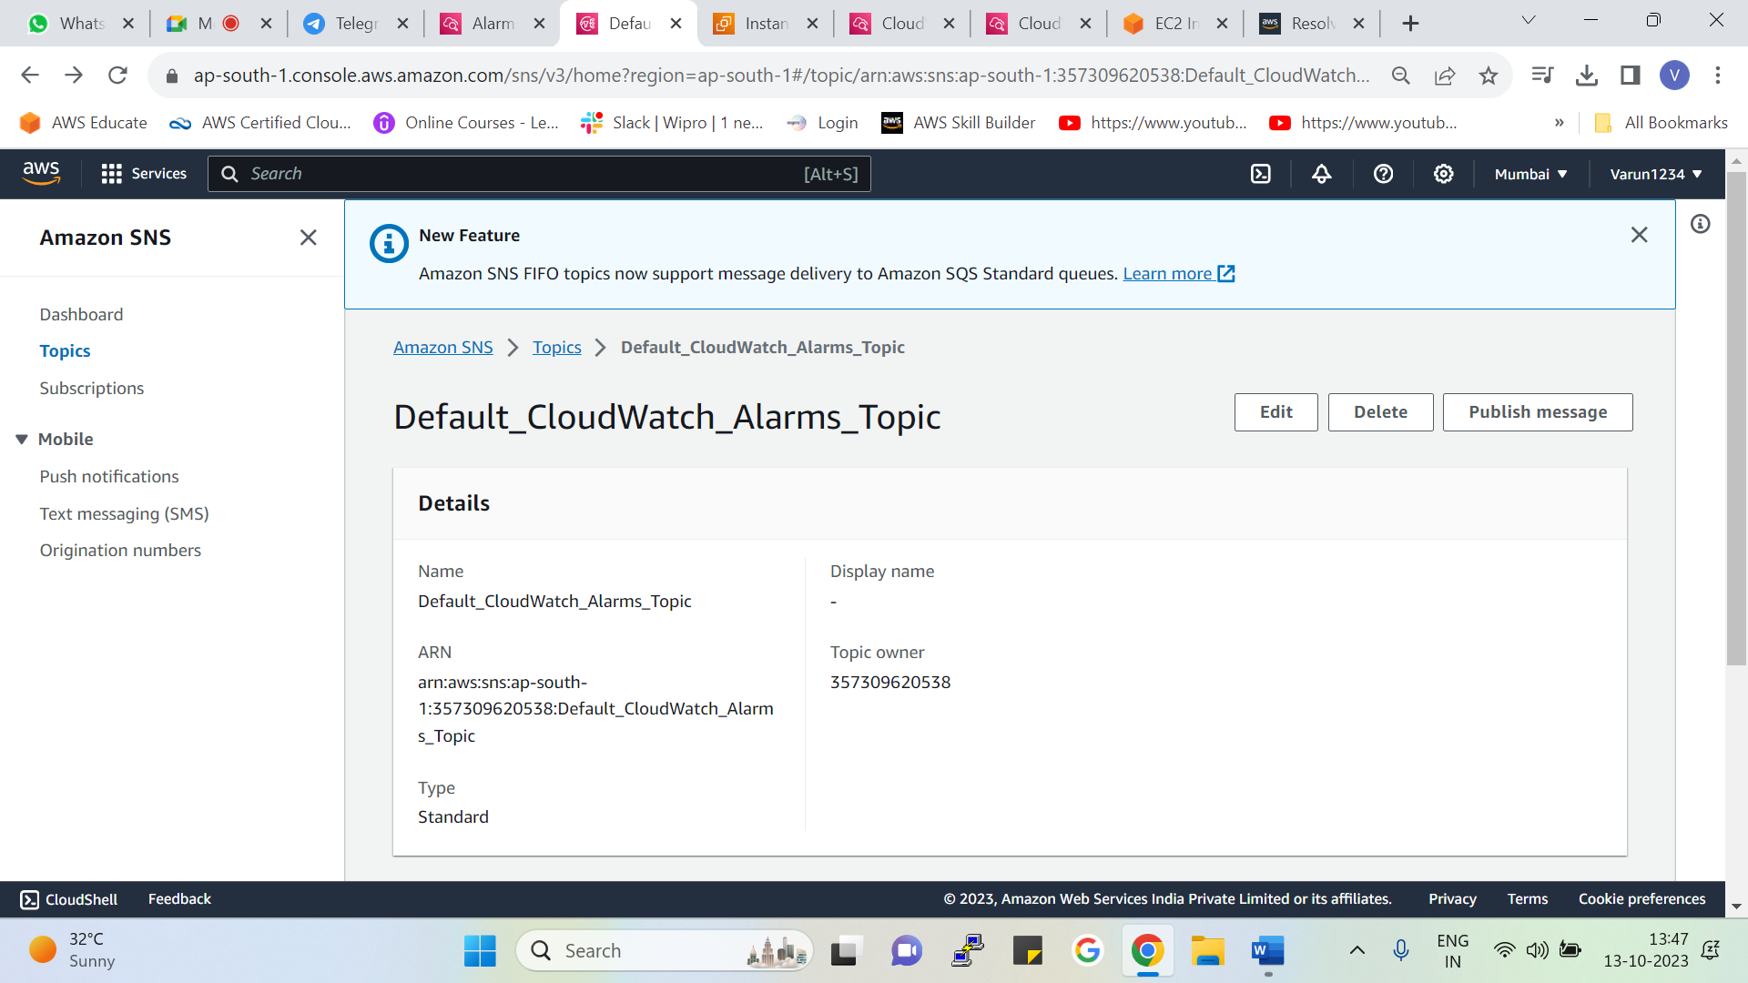

Go to edit

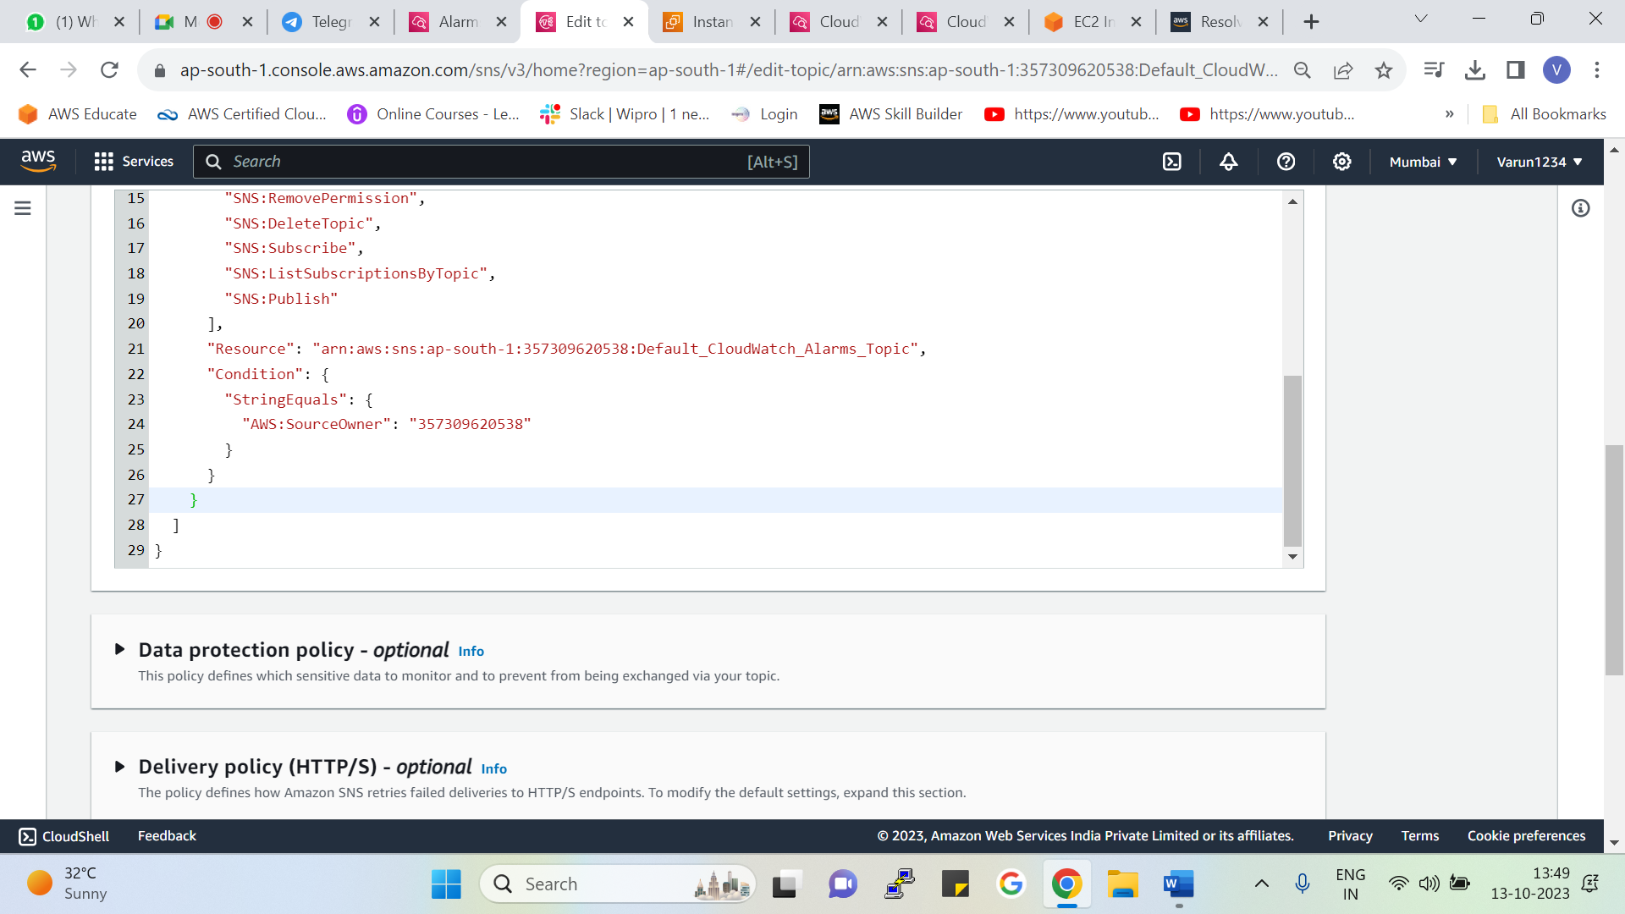



Give comma and add another statement and change the ARN

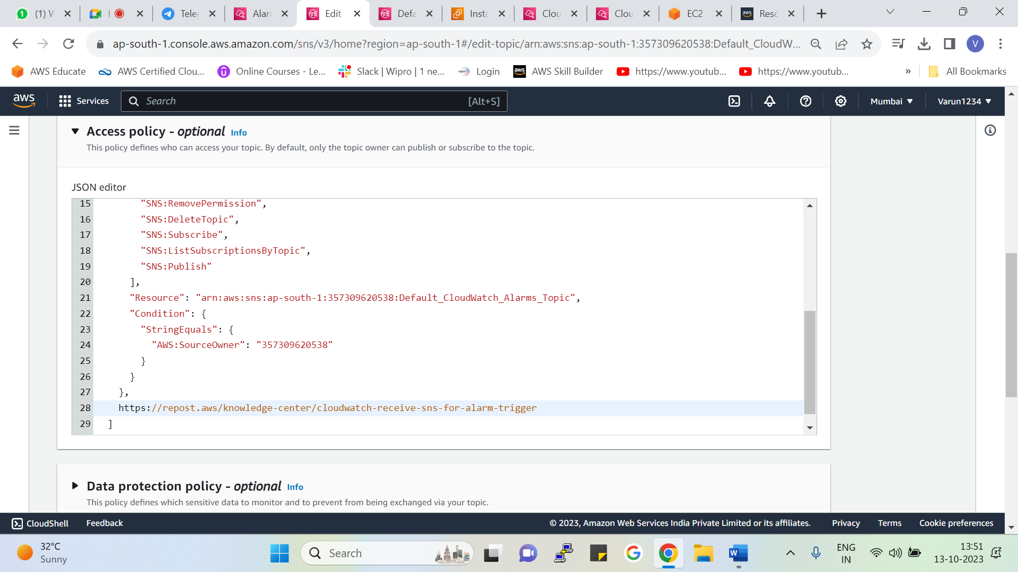



As we have pasted the policy now paste the ARN of the SNS topic

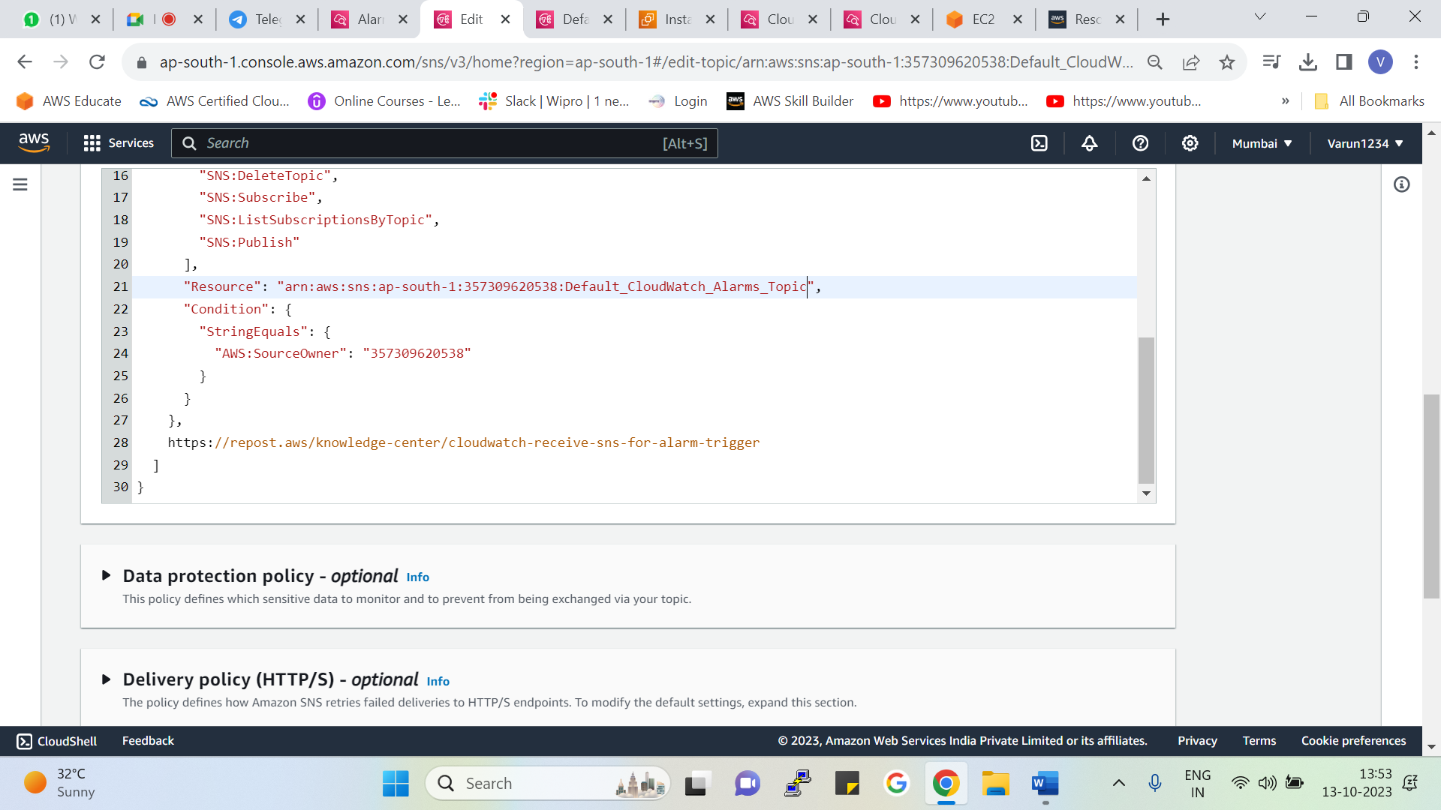



Now we have pasted the ARN

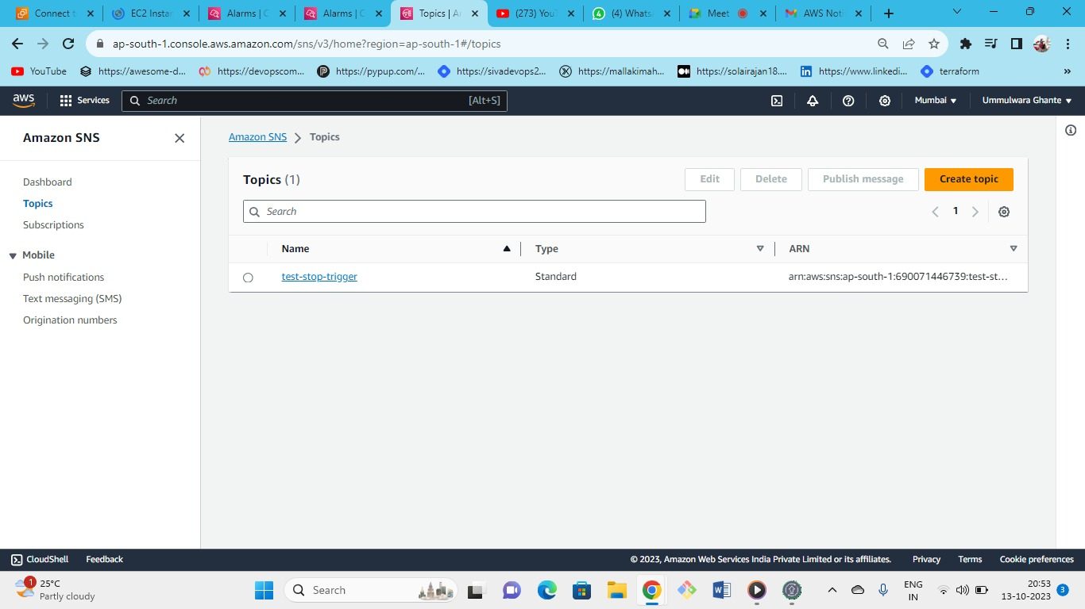



Following is the SNS topic that we have created for our alarm

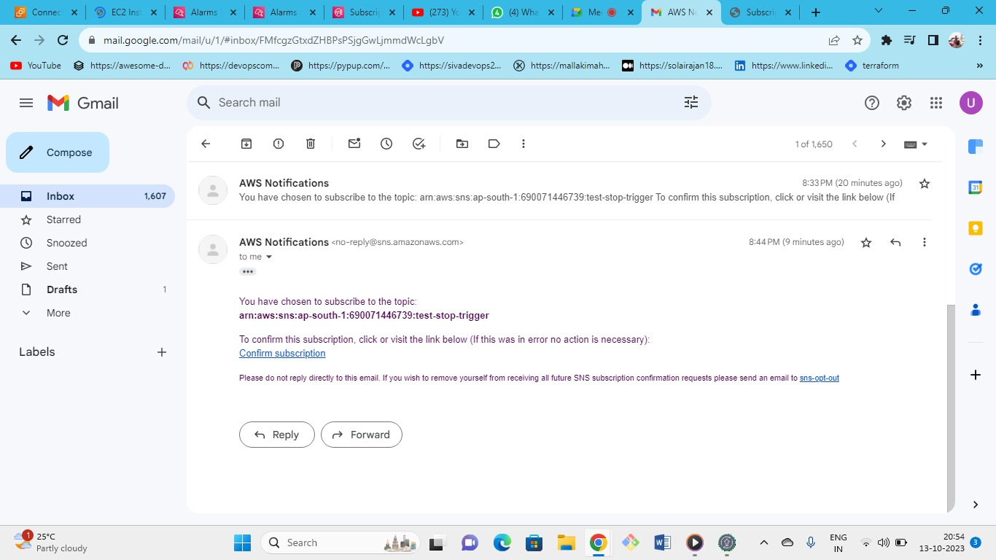



In the received email from the AWS click on confirm subscription

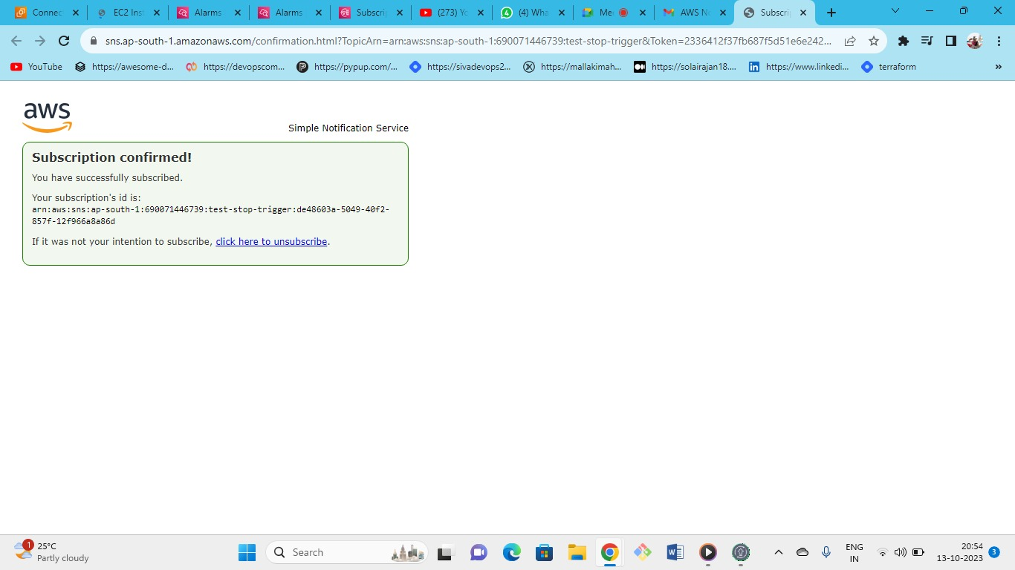



After clicking on the link provided in the email the subscription will be confirmed for SNS topic

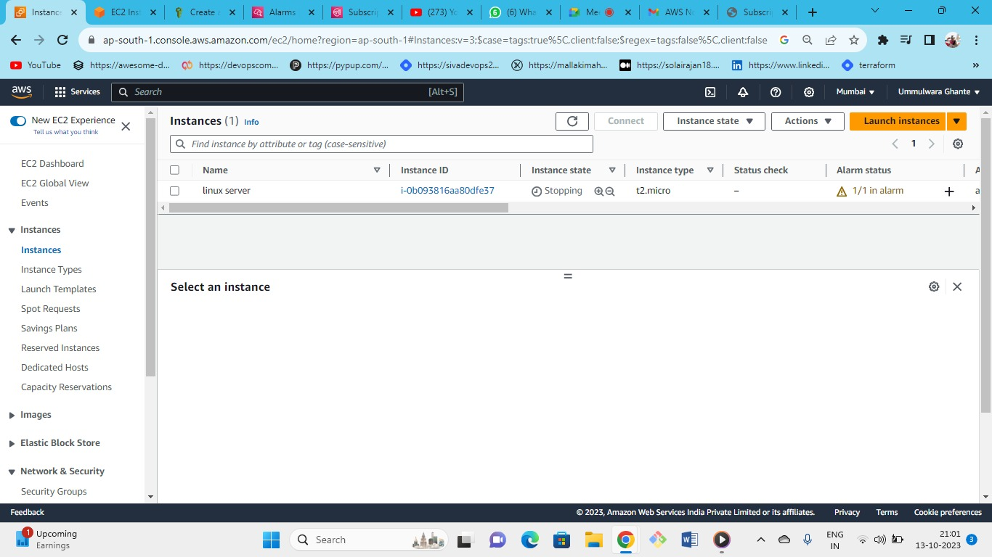



As our alarm status has crossed the threshold so alarm status is 1/1

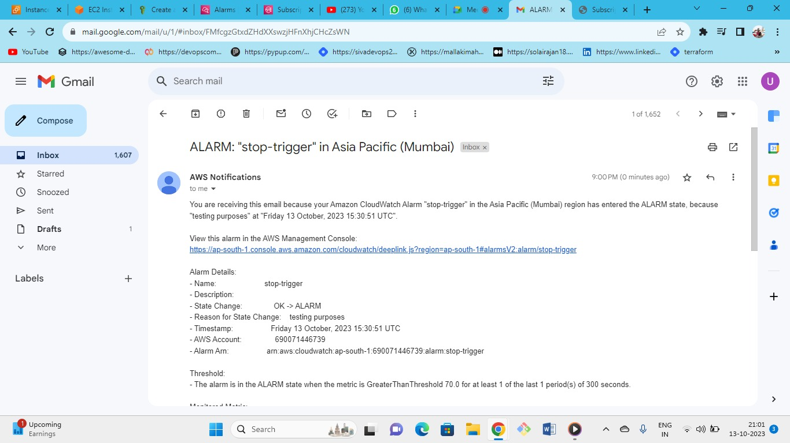



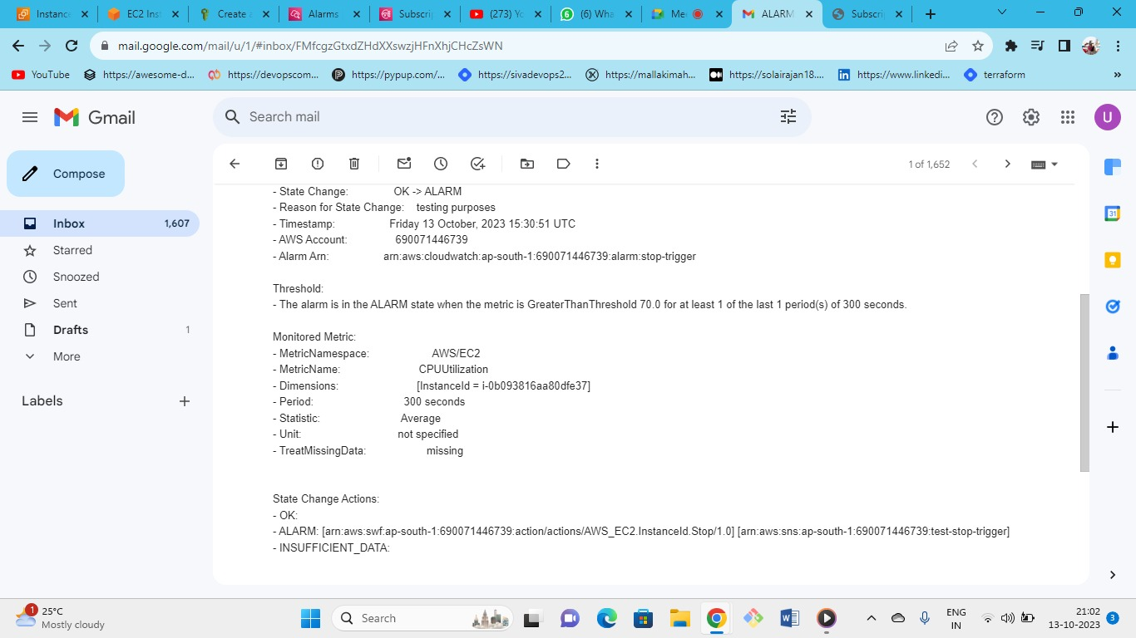



As we can see we have got the notification of the alarm on the registered email.

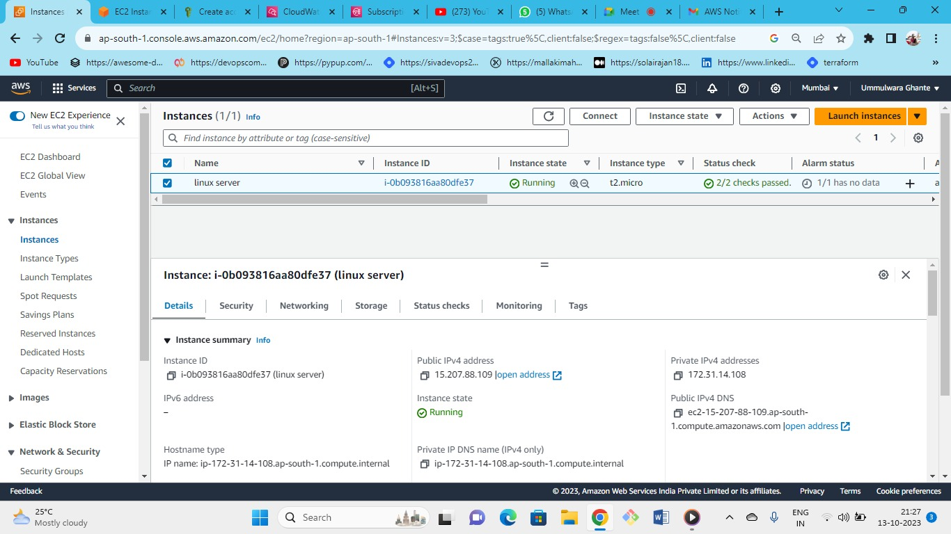



Now again start the instance

* To Stress the CPU there are some commands which are used to put the load on the CPU it is just used for testing purpose these commands are used to check its functioning properly or not.

In-alarm



Insufficient data

* You can set alarm on any metrics and you can set multiple alarms for one instance.
* You can create alarms on any cloud watch metrics

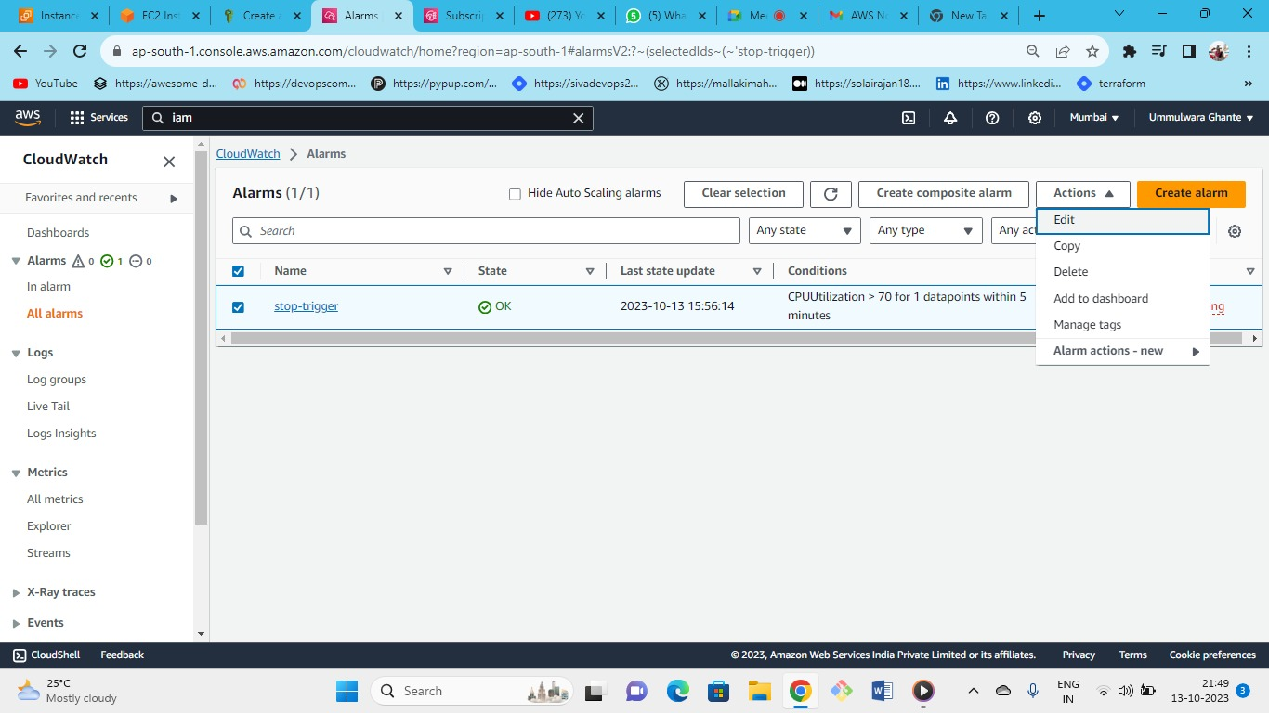



From here you can edit the alarms and its settings as per your convenience

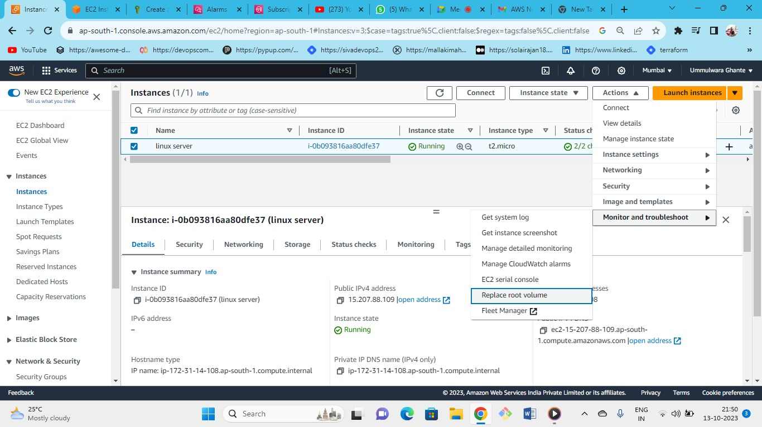

`



From here we can also replace the root volume